

Teaching for a Better Tomorrow with Tales of Strays

Margarita Kosior, Greece/Poland

Margarita Kosior is an educator, conference presenter, materials writer, but also a storyteller and a children’s author. She has written ELT materials dealing with all kinds of social issues. In recent years, she has concentrated her efforts on building and expanding her Tales of Strays Campaign, which uses storytelling, materials writing and English language teaching to talk about our responsibilities towards companion animals and about the bond between people and dogs and cats in order to prevent instances of future neglect, abuse and abandonment.
E-mail: margaritakosior@gmail.com and talesofstrays@margaritakosior.com



Background

It was spring 2014 when my children and I adopted a little kitten, Cookie, and summer 2016 when we adopted the cutest puppy ever - Mocha. The seeds for the Tales of Strays Campaign got planted, I just didn’t know it back then yet.

Why companion animals?

When I was growing up, there was always a dog in my family home - a dog as a family member. I was raised learning how to show my love and respect towards companion animals, how to care for them and how to protect them, and those were the perceptions I carried with me when I moved to Greece. But there, I got confronted with a rather harsh reality. My aim is not to publicly condemn, but I cannot not mention that beautiful Greece, just like lots of other places in the world, is a hell on earth for many dogs and cats. I have been living in Greece for over 20 years now, and a few years ago I became an active member of a local dog shelter run entirely by a group of volunteers. I know the problem of companion animals’ neglect, abuse and abandonment firsthand, and I quickly came to realise that just like in case of other global and local issues, education is the only ray of hope there is. I also understood that this specific problem concerns us all - not only animal lovers living in areas notorious for companion animals’ rights violations, but everyone on earth, and I will explain how. So, if you live in a place where you do not encounter any stray ghosts living in the shadows, please keep reading, because without doubt, there are instances of other forms of animal abuse in your vicinity; instances you may not be aware of and instances many people turn a blind eye on. So, get alert about the existence of puppy mills and ask about the origins of puppies for sale, don’t close your eyes and ears to information about dog fights, watch out for that neighbour who keeps his/her dog locked on a chain, get skeptical about the rationale behind dog racing, and learn about the simplest solution to stray overpopulation - companion animal sterilisation. Know that abuse is carried out not only when you actively hurt an animal, but also when you passively deprive them of love and care they deserve - a dog that does not know the warmth of human touch is an abused creature.

Companion animals’ welfare - an issue that matters

Introducing important global issues into an English-language classroom is nothing new. Many of us have taught about war and peace, disabilities, racism, bullying, we’ve talked to our students about animal species that face extinction and we’ve organised projects about global warming. All these are extremely important topics. They give the true meaning to the concept of educating and they distinguish it from mere language teaching. But there is this one issue that hasn’t been yet discussed in many English language classrooms in the depth it deserves – our relationship with companion animals and things that often go wrong in this relationship, or rather things that we do the wrong way, leading to companion animal neglect, abuse and abandonment. Something that has much greater implications than many of us can imagine.

It is sad to see time and time again how the seriousness and dangerousness of animal cruelty is downplayed or even totally unrecognised. Research from the 1980’s to 2018 published in Forensic Research & Criminology International Journal demonstrated that “cruelty to animals is a hallmark or signature indicator for future acts of violence, including rape, child molestation, domestic abuse, school shootings, and other forms of violence” (Johnson). In other words, a person who demonstrates abusive or cruel behaviour towards animals, can and often does become aggressive and violent towards people at some point in their lives. In fact, the same study indicates that individuals who engaged in animal cruelty were even three times more likely to commit other crimes, such as drug or substance abuse, harassement and threats, robbery, or even murder or rape. Unfortunately, cruelty towards animals is often observed in children as young as 4 or 6; frequently children who themselves have been victims of some form of abuse. Violence brings violence, so children who have experienced abuse and/or those who have performed acts of animal cruelty, are likely to later abuse in their own community, school or family (Johnson).

The way in which we treat companion animals is an important social issue, and all issues are interrelated. Helping children learn about kindness and respect towards companion animals has the potential to transfer to human relationships: children learning empathy for companion animals will feel empathy and show genuine compassion for other people, too. To convince an occasional skeptic, I will quote Ali MacGraw, an actress and activist: “I have always felt that the way we treat animals is a pretty good indicator of the compassion we are capable of for the human race.”

What does this all have to do with English language education though? According to the Humane Society of the United States, most cruelty investigated by humane officers could be resolved through education (“Animal cruelty and neglect FAQ”).

Just like in case of any other form of injustice, also in the case of companion animal education, it is easier to prevent than to cure. I personally believe that ignorance is the biggest threat; ignorance and indifference. The Tales of Strays Campaign, therefore, is my response.

Bringing the topic of companion animals into the English language classroom

I believe in the power of stories and in the power of education to bring a big change and shape minds, and an English language classroom is just the right place for this change to happen. As students are working on their English and developing their 21st century skills, they also shape attitudes and beliefs in ways which bring hope for a better future for all living creatures on this planet. And that exactly is the purpose of the Tales of Strays Campaign which introduces the topic of companion animal welfare into English language classrooms all over the world. ELT professionals can support the campaign and fight for companion animals and their rights in three ways: through storytelling, materials writing and teaching.

Storytelling

The campaign started with a picture book (“Toby to the rescue”), which I wrote and my then ten-year-old daughter Evita illustrated. It tells the story of Toby, a stray dog who lives under a tree in the park. He doesn’t have friends, and he doesn’t even have a name. When one day Toby meets Little Nick, who is taking a walk in the park with his mum, the lives of the dog and the boy change forever. Of course, Mum is always there to give precious advice about what responsibilities are involved in keeping a companion animal.

The second story, “Mae to the rescue”, is a more recent addition to the series and to the campaign. In this story, a girl named Lucy has some important shopping to do, so she goes to the shopping mall with her mum. Suddenly, when she loses sight of her in a crowd of shoppers, the little girl panics and starts crying. That’s when she meets Mae, a stray dog who offers her help. They become very good friends, but then it’s time to say goodbye …

Tales of Strays, therefore, is not only the name of the campaign, but also the title of a book series about how lives change when a child meets a stray. The stories will appeal to very young and a bit older readers thanks to engaging plots, dialogues written in the form of rhyming chants, and beautiful illustrations made by a child. The books can be used either as bedtime stories, or as educational tools raising awareness and empowering the youngest people on earth. In either case, they can be accompanied by a number of free activities and resources available on the Tales of Strays website. The online resources include memory games, word searches, and multiple-choice activities. Under printable resources, teachers will find, among others, fill-in-the-gaps activities focusing on rhyme and rhythm in the story chants, a short writing activity asking learners why they would like to adopt a dog like Toby or Mae, and the Tales of Strays contract which learners fill out and sign, in order to show that they understand what their responsibilities towards companion animals are. On the same page, there are also fun worksheets such as mazes and colouring tasks, especially useful for younger students. Last but not least, a lesson plan complete with Teacher’s notes and all the necessary resources based on “Mae to the rescue” is free for everyone to download, and a short presentation on how I use “Toby to the rescue” in my storytelling sessions will hopefully help teachers with their own work.

I have personally taken the Tales of Strays picture books to storytelling sessions at preschools and language schools in Greece but also abroad (e.g. Serbia, Argentina, and Kazakhstan), and have been amazed by the level of student motivation and engagement during those sessions, but also by the children’s innate capacity to empathise with animals lacking love, care and devotion they deserve.

Materials writing

Every year, Tales of Strays supporters and friends celebrate World Stray Animals Day (4 April) with a publication. The first volume, “The human-animal bond and what it enTALES” released in 2020, is a compilation of 11 lesson plans written by educators and materials writers from all over the world. The title of the second publication (2021) is “ELT for companion animals” and it contains another 11 contributions. The most recent volume, “Tales of Strays: a compilation of lesson plans. Volume 3”, was launched in April 2022. The entries for this year’s compilation came from Romania, Moldova, Kosovo and Greece, and they automatically entered a competition for the best lesson plan. The winning entry was submitted by Irina Pomazanovsky from Moldova, and the three runners-up - Lia Bezanidou, Charikleia (Chara) Chalatzouka and Anna Petala - are all based in Greece.

Irina created a lesson plan with the self-explanatory title "The role of companion animals in enhancing human well-being" - it is a lesson about the ways in which animals make us feel better. It is aimed at B1+ students. During the lesson, learners get a chance to develop not only their language skills, but also their 21st century skills. The session begins with a few intriguing hints which allow students to guess what the topic of the lesson is going to be. Then, they engage in a warm-up discussion about pros and cons of keeping a companion animal. Students divide the advantages into three groups: physical, psychological and psychosocial. Then, they read a number of statements and express their opinions and make predictions, as during the next stage of the lesson, they will be invited to watch a short video about the influence of companion animals on human well-being and check whether their predictions were right.

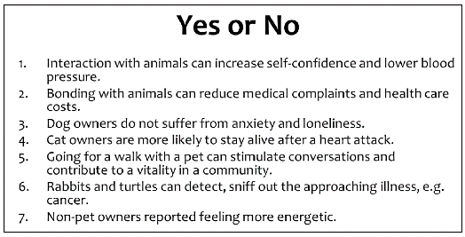

In the last part of the lesson, students are asked to work in groups to make some decisions. This stage develops their critical thinking and negotiation skills, and engages them in meaningful speaking practice. Each group gets a profile of a person who is looking for a companion animal. The groups need to come up with two suggestions each and justify their choice: Why do you think this person will enjoy the company of a companion animal? How will the company of an animal benefit him/her?

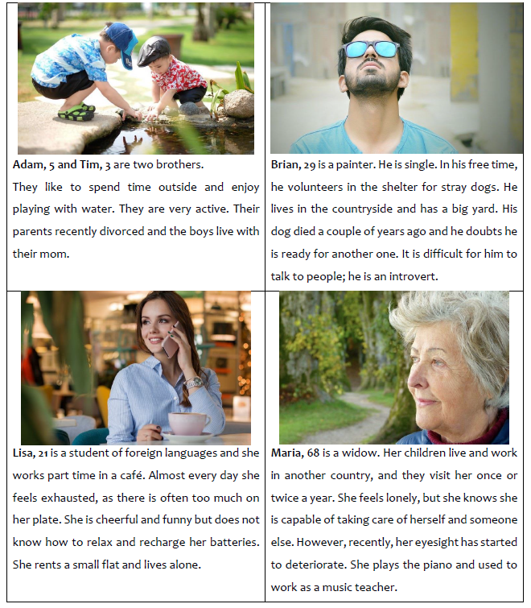
During a suggested extension activity, students prepare a presentation of their own companion animal (or the animal they know or would like to have); it gives them a wonderful opportunity to talk about how much better their lives are (or would be) thanks to their dogs or cats.

Lia’s lesson titled “Credo, my loyal friend” is about grief, and it was inspired by real-life events. It is aimed at B1-B2 learners. During the lesson, students acquire and practice vocabulary related to grief and feelings, and they develop all language skills through a variety of activities.
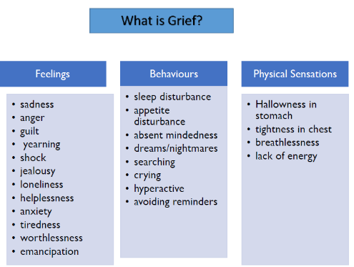
An extract from Lia Bezanidou’s lesson plan

The first part of the lesson is built around the photograph of Credo - Lia’s late companion who was the inspiration for the lesson - and a discussion follows.

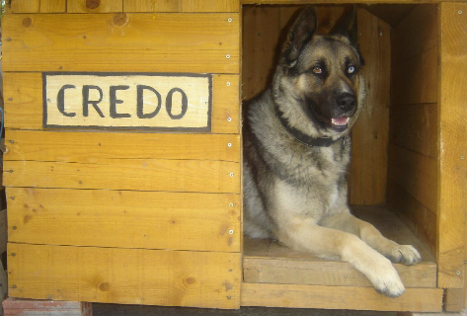
Photo credits: Lia Bezanidou

In order to initiate the discussion, the teacher reads out the following: “When people who have never had a dog see their dog-owning friends mourn the loss of a pet, they probably think it’s all a bit of an overreaction. After all, it’s 'just a dog’. However, those who have loved a dog know the truth: Your companion animal is never ‘just a dog’.” So, is it, or is it not ‘just a dog’? And is it right to compare the loss of an animal with the loss of a human being? Students agree and disagree, using the functional language provided in an appendix. Moving on, they work with a story about Credo written by Marina, Lia’s daughter, and get a chance to discuss another difficult topic - the topic of companion animal euthanasia. This discussion makes a transition to the second part of the lesson which is built around a video clip. Students are asked to write the story presented in the video clip - the story of a girl rejected by her peers but loved unconditionally by her dog. How did the dog make the girl feel, and how does she feel when it is time to say goodbye? The lesson concludes with students’ reflections on a painting made by another student - a painting in which the artist used her own medium to illustrate what loss feels like for her.

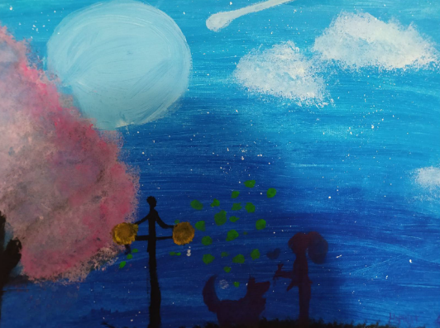
“Loss of a companion animal” by Marina Kilinkaridou

Lia’s lesson plan is a very personal journey, and it is written with the deepest respect for companion animals crossing the Rainbow Bridge and for their human families left behind, mourning their loss.

One of the main aims of Chara’s lesson plan "A stray’s life in motion" is fostering creativity - the aim which she achieves through experiential learning and through the medium of theatre and drawing. It is aimed at younger learners, at the age of 9 to 11, and level A1+ on the CEFR scale. The lesson is based on the picture book “Toby to the rescue”. At the beginning, the teacher makes sure that students understand the terms “stray” and “companion animal” - this is done through images provided by the author of the lesson plan in appendices. During a discussion that follows, students talk about stray animals in their town/city, about the feelings involved, and about actions the students take to help those strays. The main part of the lesson involves reading out the story - the children get to meet Toby and his friend Nick, and they learn about our responsibilities towards dogs and the beauty of adopting a stray. Comprehension tasks based on the story follow. During the second part of the lesson, students get engaged in a series of creative activities: they act out parts of the story, create puppets, and use their imagination to continue the story and then dramatise it in front of their classmates. As Chara put it in her lesson plans, “The main purpose of this lesson is to enable Ss to think creatively as well as explore the characters’ feelings and thoughts through artistic expression.”; an aim beautifully achieved, as we can see in the pictures from Chara’s lesson with her own students.

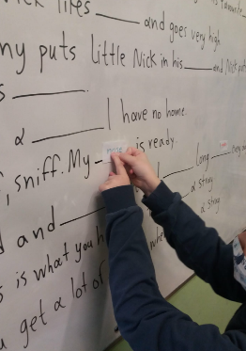
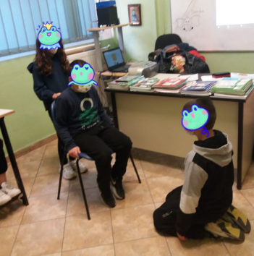

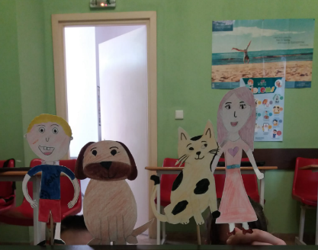
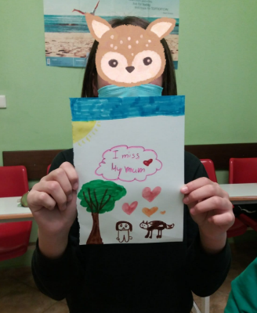

Last but not least, in her lesson plan aptly titled "Jackpawt!" Anna tells us all about how her dog Evita adopted her! The protagonist of the lesson is Evita, a beautiful former stray, and the lesson is aimed at B1+/B2 students. The warm-up stage of the lesson leads students into the world of strays in a unique way. The teacher asks students to close their eyes and imagine that they are dogs and they have no home. The author suggests: “Tell them in a soft voice: You are hungry, dirty, you may even be sick. You are trying to find a safe spot to sleep when suddenly…” At this point, the teacher plays an audio file with a sound of pouring rain and asks students to consider their emotions and share them with the rest of the class. What a beautiful start to a lesson during which students will develop their empathy and talk about their feelings. During the next part of the lesson, students read a text which narrates the events on 13 June 2016 when Anna saw Evita for the first time, adopted her (or was it the other way round?), and tells us how the story unfolded. This account is followed by a number of dynamic activities which allow students to develop their language skills, but also their 21st century skills. The lesson ends with a task based on a short video with the photographs of Evita. In this task, students are asked to write about Evita’s feelings before and after her adoption. A touching take-away - a message from Evita: “If you enjoyed my story and perhaps feel a bit jealous, open your arms, your hearts and home to an animal with no family and you never know, you may, too, hit the jack-paw-t!”
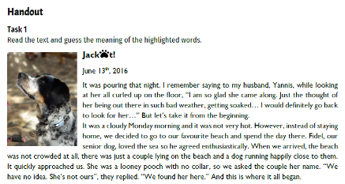
An extract from Anna Petala’s lesson plan

The four lesson plans were selected by the international team of judges - Barbara Hoskins Sakamoto, Dede Wilson and Rakesh Bhanot - who embraced the campaign and supported it with their expertise. To me, all the contributing authors are winners. They are professionals who have decided to use their most powerful weapon - education - to speak for those who cannot speak for themselves – for those whose basic rights are often violated: companion animals. The next step is made by teachers - fantastic educators in various places around the world who download the compilations and use the lesson plans with their students. Without them, our efforts are futile.

Teachers who are willing to support the cause through materials writing can consider designing a lesson plan for a future compilation, on an issue related to the broader topic of human relationship with companion animals (e.g. responsible dog/cat adoption, understanding dog body language, therapy dogs), teaching values such as compassion, commitment, empathy, etc. The lesson can be designed for an age group and CEFR level of the author’s choice. The author is not expected to directly speak about animal neglect and abuse. Instead, they can choose to highlight the beauty of our relationship with companion animals and nurture positive behaviors towards them, rather than directly condemn negative attitudes. I feel we can have a more powerful effect this way. Any teacher or materials writer willing to participate can send a message to talesofstrays@margaritakosior.com to express interest in contributing. Every year, compilations are uploaded to talesofstrays.com - the place which I currently use for Tales of Strays related activities - and made freely available to anyone who would like to spread awareness of the problem of stray companion animals worldwide.

Teaching

No matter how creative and engaging the materials in the Tales of Strays compilations are, they would not make much of a difference in the world if it were not for the inspiring teachers willing to bring the topic of companion animals, their well-being, but also so frequent neglect and abandonment into their lessons. Since the lesson plans included in each compilation provide detailed Teacher’s guide and ready-to-use materials, they can be used by both experienced and less-experienced educators.

In order to become an official Tales of Strays supporter, throughout the academic year, the teacher or school needs to commit to delivering at least four lessons of their choice from the existing compilations or to suggest their own ideas or projects and work on them with their students. Since the campaign can only grow if we get the word out there, teachers try to support the cause on social media by posting samples of their students’ work and their reflections. This way, we can get more teachers and students involved, and make an even bigger impact.

Since the release of the three compilations, teachers in various countries have used those lesson plans in their classrooms to introduce their students to the issue of companion animals and our responsibilities towards them, and have talked about the plight of stray dogs and cats. We've seen some amazing projects - posters, pictures, reflections, videos, poems – you name it! – created during and as a follow-up of those lessons.

A final word
Gandhi said: "The greatness of a nation and its moral progress can be judged by the way its animals are treated." The Tales of Strays Campaign, based on its three pillars - storytelling, materials writing and teaching - and aiming to change our attitudes towards companion animals, can only take us forward. By highlighting the beauty of our relationship with companion animals and nurturing positive behaviors towards them, we hope to and we will create a world in which kindness and empathy prevail.

You may have noticed that I do not use the term “pet”, and I choose the term “companion animals” instead. I never speak about “pet owners” either. That is because I believe that words have the power to define who we are and what our place in the society is. In my personal opinion, the term “pet” implies that an animal is there for your own pleasure, whereas a companion animal is a creature that you share your life with. You don’t own a companion animal. You live with them, you guard them and you protect them. Mocha and Cookie are not my pets. They are my family and my inspiration.

More information about the campaign can be found on my website, on our Facebook page, and on Instagram.

References

Johnson SA. Animal cruelty, pet abuse & violence: the missed dangerous connection. Forensic Res Criminol Int J. 2018;6(6):403-415. DOI: 10.15406/frcij.2018.06.00236

The Humane Society of the United States (n.d.), “Animal cruelty and neglect FAQ”: https://www.humanesociety.org/resources/animal-cruelty-and-neglect-faq#:~:text=Most%20cruelty%20investigated%20by%20humane,mutilating%20or%20killing%20an%20animal

Please check the Pilgrims f2f courses at Pilgrims website.

Please check the Pilgrims online courses at Pilgrims website.

