Letter 1

Hi Hania,

I hope all's well with you and that you are not suffering from too much extreme heat.

I just wanted to thank you for the latest edition of HLT. I'm thrilled to see so many contributions from Uzbekistan, where I have spent so much time over the last 18 years. This reflects the growing sense of professionalism among English teachers there and it's great that you have helped them to find their voices internationally. I'm working with a group of Uzbek teachers at NILE this summer and I'll draw their attention to the issue.

The whole issue is unbelievably rich and I'm looking forward to digging into it over the weeks ahead. You really do a fantastic job as editor.
Warm wishes

Rod Bolitho

Letter 2
Dear Hania,

I hope all is well. Allow me to share my recent article.

https://www.taiwannews.com.tw/en/news/4598408

Best regards,
Adam Borowski

Letter 3
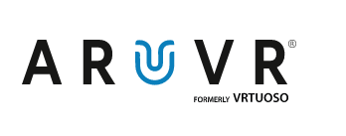
Hi there,
I am writing to introduce ARuVR – the pioneering virtual reality platform, designed for enterprise with learning and development in mind.

Our platform is transforming the way our clients deliver training, learning and development in the following areas:
- Health and safety
- Hazard perception
- Product familiarisation
- Location orientation and onboarding
- Soft skills, (e.g. diversity awareness, empathy, and public speaking)
- Site inspections
According to PwC, training delivered in virtual reality improves user performance by 70%, content retention by 75% - 90% and has increased engagement rates of 95%.

Historically, the cost of creating VR content was a barrier to delivering a large amount of training in this manner. The ARuVR platform changes that, with our super-easy authoring tool enabling subject matter experts to create their own VR presentations without the need for an expensive external agency. Some of our clients say it is as easy to use as PowerPoint.

The best way to learn more about ARuVR is by scheduling a call, during which I can provide you with a demo of our platform and answer any questions you may have.

Kind regards,
Ainsley Henn
Business Development Manager, ARuVR

Phone +44 (0) 7803 538392
Mail ainsley@aruvr.com
Website aruvr.com

Letter 4
Dear Hania Kryszewska,
I would like to introduce my 60 minutes documentary 'Dreaming of Words' to you.
The documentary film is about Njattyela Sreedharan, a fourth standard drop-out, who compiled a dictionary connecting four major Dravidian languages. Travelling across four states and doing extensive research, he spent twenty five years making the multilingual dictionary. This unique dictionary offers a comparative study of Malayalam, Kannada, Tamil and Telugu. 'Dreaming of Words' traces Sreedharan's life, work, love for languages and the struggles to get the dictionary published. The film also explores the linguistic and cultural diversity in India.

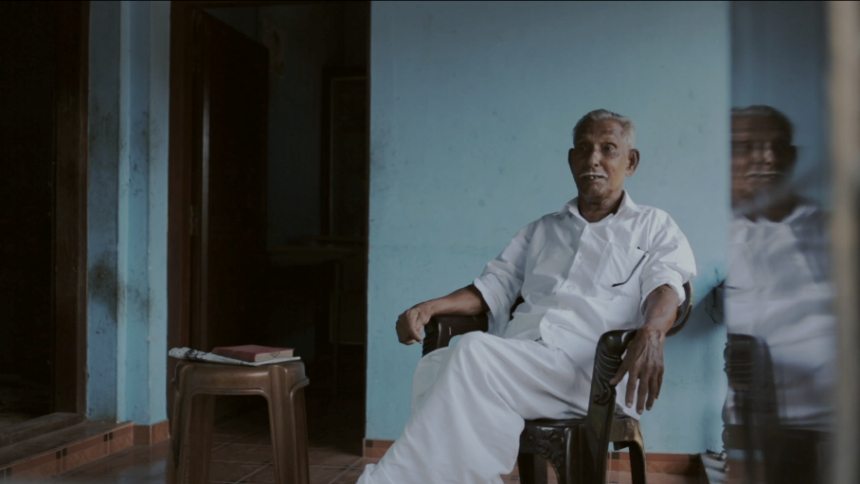
'Dreaming of Words' had its world premiere at the International Mother Language Day Celebrations 2021 organized by the Indira Gandhi National Centre for the Arts and the Ministry of Education (India) in partnership with UNESCO.
It was an official selection at the DC South Asian Film Festival, RapidLion Film Festival and Micheaux Film Festival. It won the Kerala State Television Award for Best Educational Documentary.

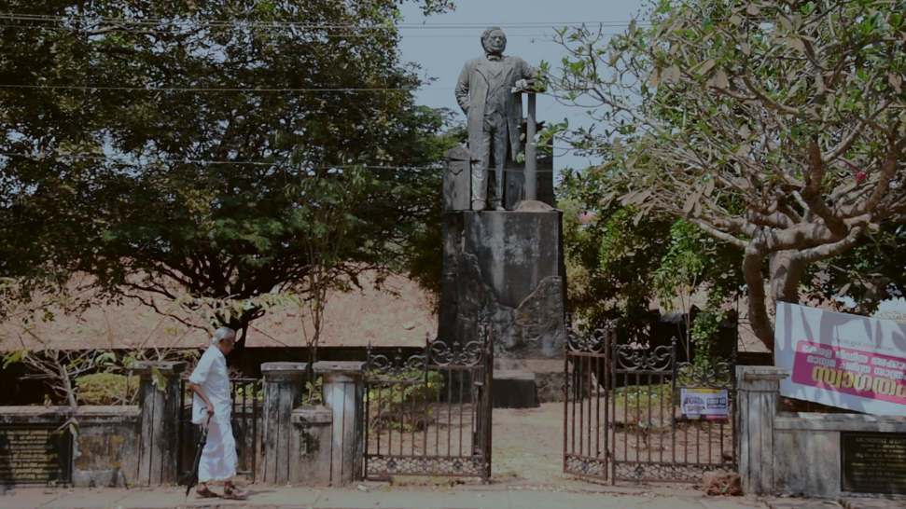
It was screened at the annual convention of the Modern Language Association and the annual conference of the Linguistic Society of America in January 2022.
https://en.wikipedia.org/wiki/Dreaming_of_Words
https://www.imdb.com/title/tt13150132/
Here is the link to the trailer: https://youtu.be/yh450c0u0Ag
The film is now streaming on the following OTT platforms:
Amazon Prime Video - https://www.amazon.com/gp/video/detail/B09ZKDT199/ref=atv_dp_share_cu_r
Gumroad - https://nandansdreamfactory.gumroad.com/l/DreamingofWordsEng
MovieSaints - https://www.moviesaints.com/movie/dreaming-of-words
Kindly consider sharing about the release of 'Dreaming of Words' in your page. I believe that 84 year old Njattyela Sreedharan's story will be inspiring for many. I have attached the poster and a few stills of the film along with this mail. Looking forward to hearing from you.
Thanks and regards,
Nandan.
https://www.imdb.com/name/nm1105965/

Letter 5

Resources designed to help you nurture young people’s health, skills and confidence across a range of age groups.

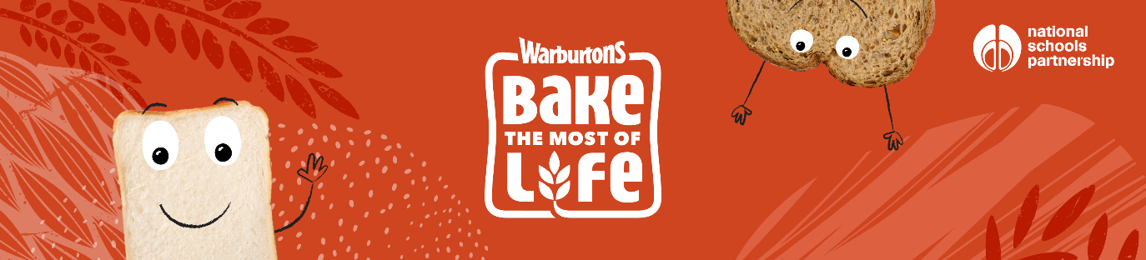

Dear Colleague,
Bake the Most of Life, a free education programme by Warburtons, is available to schools across the UK right now. It’s designed to ‘bake-in’ the skills and confidence young people need to live their best lives and features easy to use curriculum-linked resources.

This no-grainer of a resource covers a whole loaf of subjects including:
- English
- Geography
- Science
- Art and Design
- PSHE
Seriously, what are you wheating for? Get involved now!

World of Bread (ages 5-7)
Take your pupils on a whistle stop tour of the world with our exciting and interactive resources, reinforcing the importance of a healthy lifestyle, and sparking a curiosity for the world around us.

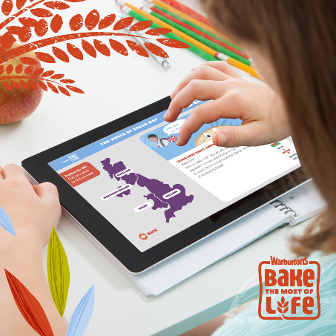

Grain to Plate (ages 7-11)
Bring the food journey to life by taking your pupils on a hilarious comic adventure with our hero Goldie Grain. Watch her epic journey, starting as a tiny seed filled with so much promise and transforming into a tasty bun, destined for butter things...

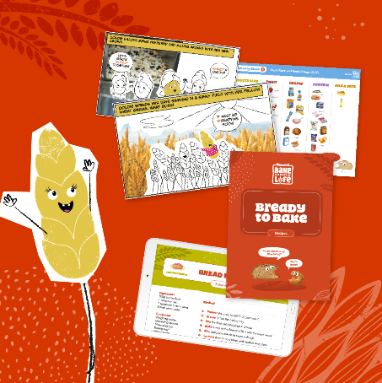

Innovation Team Challenge (ages 11-14)
‘Ready to roll’ lesson plans and engaging PowerPoints will guide students through a series of workplace learning lessons. The brief is simple: create and launch a new bakery product that will blow Warburtons’ rivals out of the water. Along the way, students will develop the transferrable skills needed to succeed in the workplace, including teamwork and communication.

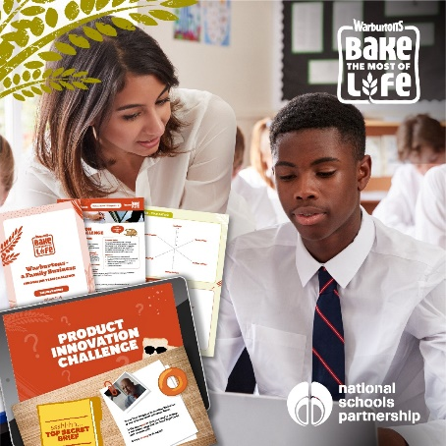

Get your class involved

Dough-nut miss out on these curriculum-linked resources, created by education experts and oven-ready for the classroom. You’ll have access to delivery guides, PowerPoint lessons and activity sheets across each module.
Help your students prepare for their future and sign up today.
Louise Weisbloom,

TeachingTimes
205 The Jubilee Centre, 130 Pershore St,
Birmingham, B5 6ND, UK,
Tel: +44 (0) 121 224 7599 | Fax: +44 (0) 121 224 7598
www.teachingtimes.com | enquiries@teachingtimes.com

Letter 6
Hello !
I'm Kiara , Digital Marketer from LearnVern.com
My attention was drawn to your website and which is relevant to our niche. I’m reaching out to check if you are accepting guest post contents. LearnVern is a name coined from the word Learn in Vernacular Languages. We teach students in the user's native language for FREE. Our Courses are designed & curated by experienced professionals that will make the learner industry-ready.
We want you to help us in this initiative and reach more people by allowing us to post for FREE on your website. All we accept is just one do-follow link in return.
To give you an idea of the quality content that I can bring to the table.
- 1200+ Words Content
- Google Friendly Content & Images Attached
- Non-Promotional & Informative Content
- Zero Plagiarism
- Premium Grammarly Passed Content
- Readability Score above 90+
All these reports are attached with content.
Thanks & Regards,
Kiara Irani

