Cooperative Learning and the Sustainable Development Goals from Peachey Publications

Have you been searching for new ways to create a more student-centered learning environment for your students? If so, Cooperative Learning and the SDGs, a free online book about the interface between cooperative learning and the UN’s Sustainable Development Goals, may provide you and your students with new communicative activities that incorporate the SDGs.

Although many ministries of education are appealing to teachers to incorporate the SDGs, few road maps are provided to teachers on how to implement sustainability content. Cooperative Learning and the SDGs provides sustainability-related lesson activities that have been adapted from an assortment of authors who have published lesson materials related to sustainability.

In the spirit of cooperative learning, the authors of Cooperative Learning and the SDGs felt that drawing inspiration from outside authors’ material would broaden the overall scope of the textbook. A book written by teachers (seven of them) for teachers; please navigate to the Peachey Publication website and discover a cornucopia of educational materials, including our textbook, Cooperative Learning and the SDGs.

Download the full text from: https://payhip.com/b/obOwr
You will get a PDF (37MB) file

Written by:
Lim, S., Reidak, J., Chau, M. H., Zhu, C., Guo, Q., Brooks, T. A.,Roe, J. and Jacobs, G. M.
Published by PeacheyPublications Ltd UK 2023
186 Pages (PDF)
Contact: Jesse Reidak, jesse.reidak@gmail.com

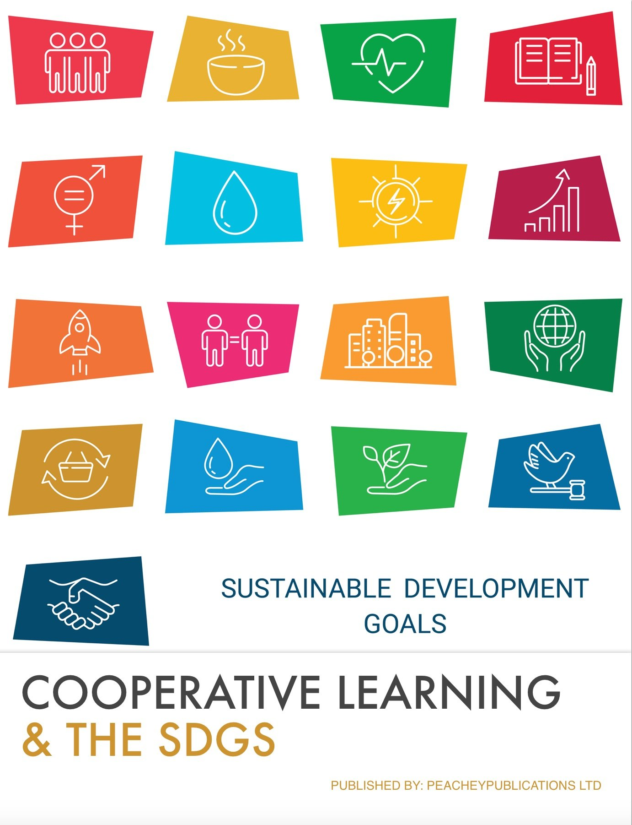

Cooperative Learning and the Sustainable Development Goals is a comprehensive guidebook designed exclusively for English language teachers. This invaluable resource is packed with a diverse collection of lesson plans, expert tips, and innovative teaching techniques, empowering educators to seamlessly integrate cooperative learning strategies into their classrooms while nurturing students' deep understanding of the Sustainable Development Goals (SDGs).

With its practical approach and rich content, this book equips teachers with the tools they need to foster collaborative environments, enhance language proficiency, and cultivate global citizenship through engaging and impactful lessons. Whether you're a seasoned educator or just starting your teaching journey, this book is an indispensable companion for weaving together cooperative learning and the transformative power of the SDGs in your classroom.

From the Introduction

The Earth contains more than eight billion humans. That means we have more
than eight billion brains to think and understand, and more than eight billion hearts
to understand and care. This book is about helping all those wonderful brains, and
sincere hearts cooperate to improve the Earth for everyone.

One map for improving the Earth is the United Nations’ Sustainable Development
Goals (SDGs). Many of us already know about the SDGs, and we may have
different opinions about the SDGs, just as we have different opinions on many
matters. Nevertheless, perhaps we can agree for the sake of this book that the
SDGs can be a flexible starting point for seeking improvement.
Just as there are different opinions about the SDGs, there also exist different views
on how to attempt to achieve the SDGs. In this book, we focus on education, and
within education, we focus on a method known as cooperative learning (CL). It
goes by other names, such as collaborative learning, but for the sake of simplicity,
we will call it cooperative learning. With CL, students of all ages work together with
peers and others to achieve learning and other goals.

An inclusive book

In this book on using cooperative learning to achieve the SDGs, we, the authors,
try to be inclusive in several ways. First, we try to write without jargon, in
reasonably simple terms, using many examples to explain the ideas we are
sharing. By the way, many of the concepts and ideas in this book have been
inspired by a wide variety of sources and authors. We share these ideas with you
and hope you will share them with many others.

Another way we try to be inclusive with this book is by making the book available
for free online. Many books can be expensive, and the costs go even higher with
shipping fees. Free online books can be obtained by anyone with access to the
internet and shared readily. However, we do realize that too many of us, eight
billion humans, do not have easy Wi-Fi access or do not speak English, the
language of this book. We need to improve.

One more way that we hope to make this book inclusive is by having examples of
all the 17 SDGs, and examples that work for many different students and teachers,
regardless of age and other background factors, including where people live. Of
course, we cannot provide examples that work for everyone. This is where we
need your help. We need you, and those with whom you learn and strive, to
develop more examples.

