My Journey as a Learner and User of English
Semanur Aras, Türkiye
Semanur Aras is a research assistant at Kahramanmaraş Sütçü İmam University (KSU), Türkiye. She started her university journey in the Basic English Department at Middle East Technical University Ankara (METU). After completing her Bachelor's degree in Science Education at METU, she pursued further studies and obtained her Master's degree from KSU in the same field. Currently, she is preparing to embark on her doctoral journey starting at the time when this article is issued. E-mail: smnra36@gmail.com
To start with
For me as an academic, it is critical to remain up-to-date on global developments, which necessitates proficiency in English. I hope to maintain a genuine curiosity for acquiring new knowledge, exploring diverse cultures through travel, and engaging with individuals from various backgrounds.
So, English has gained considerable significance for me even though I see myself as a science educator. On my English journey, I have experienced many ways of learning the language. I want to think about the teachers, methods, activities, and other opportunities that contributed to my learning. I hope that my reflections are informative for those who have the task of teaching English and inspiring for those who seek to learn the language.

Teachers, programs, methods, and techniques: Learning inside classroom walls
My English journey started when I was a pupil in middle school. Our first teacher wanted to repeat each sentence in English. By doing this, my English improved a lot because while repeating, I had to memorise words and was able to remember them. I gave little importance to English at that time because I did not need the English language to be successful in high school entry exams. Within the overall grading system, the coefficient of the English exam score was extremely low.
When I started high school, I had a great teacher. In the first days of our lessons, I asked her how I could improve my English and what I should do. She gave us graded readers with funny stories. Firstly, I read the book and highlighted the points that I didn't understand. My teacher also spent her time reading with me. I asked her about all the words that I did not know in the reading, and I started to enjoy English. She encouraged me to take a private English course in the summertime. I had the opportunity to meet with foreign people and to chat with them in the course. I noticed that I love speaking English because I could achieve something. I tried to think in English every time. For example, while I was walking, I was thinking about the word to walk.
I then decided to study science at a university in Ankara, where programs were run with English as the medium of instruction. Even though the fact that the university's medium of instruction was English did not play a role in the decision to study there (actually, my father encouraged me to receive my tertiary education there), in retrospect, I am happy that I had the opportunity to study at such a university. I attended the English preparatory courses in the Basic English Department in the first year, and I improved myself a lot. Our first teacher at the university was from England. He was not able to speak Turkish, so we had to speak English with him all the time. I carefully chose the words a day before I would have a talk with him in the classroom, and I noticed that when I used the words again and again, I would remember them. I talked with myself loudly to correct my pronunciation so I could speak correctly in the classroom.
My second teacher in the Basic English department taught us how to write accessible and accurate essays in English. He taught us many clues about writing in English. Using different words and conjunctions is essential, and, of course, I know that the three critical components of an essay are introduction, body, and conclusion. In the introduction, it is vital to provide relevant information about the topic. The second part should delve into the subject matter by offering examples and detailed explanations. Concluding the essay involves presenting consequences and revisiting previously discussed ideas. Reflecting on my experience, my last teacher in the Basic English department placed significant emphasis on the memorization of English vocabulary. She distributed word sheets, fostering an environment where we would repetitively practise words in the classroom. This method extended to learning synonyms for a multitude of words.
The entire journey proved to be quite challenging for me. Failing to pass the English Proficiency Exam would have necessitated repeating the English courses for another year. The prospect of this outcome induced stress and nervousness within me, underscoring the significance of success in this examination.
Throughout my English learning journey, I encountered a diverse collection of instructors. It became abundantly clear to me that teachers play a crucial role in shaping one's relationship with a language through their instructional methodologies. Upon graduating from the Bachelor's program, I undertook the task of securing employment. Fortunately, this process unfolded relatively smoothly for me due to my proficient level of English. The prerequisites for the Research Assistant position included two examinations: the English proficiency exam administered in Türkiye (YOKDIL/YDS) and the ALES exam (comparable to GMAT or GRE). Despite giving only a week for preparation, I felt adequately equipped for the English exam, having already attained a sufficient level of proficiency through my prior studies.
Travel, exchange, projects, and other opportunities: Learning outside classroom walls
I travelled Europe with the Erasmus internship programme. Before going to Europe, I had to find a place to do my internship. While looking for an internship, I contacted many people via email. My proficiency in English facilitated seamless communication, enabling me to interact with individuals across diverse backgrounds and cultures effectively. During my enriching journey across Europe throughout the Erasmus internship program, one key aspect stood out: communicating effectively with locals - because they rarely speak English. Throughout my sixty-nine-day stay, I seldom felt like a foreigner due to the ease with which I interacted with people. Understanding and being understood were effortless, making integration into diverse cultures remarkably smooth. However, there was an extraordinary exception to this experience. I encountered a challenge when I missed a train in a city situated beyond the central areas, where English of the locals around there was apparently limited. When I asked people about the train, they couldn't understand me, and I missed the train. Despite my efforts to locate the train station, I found myself disoriented, afraid, and in need of assistance in the English language.
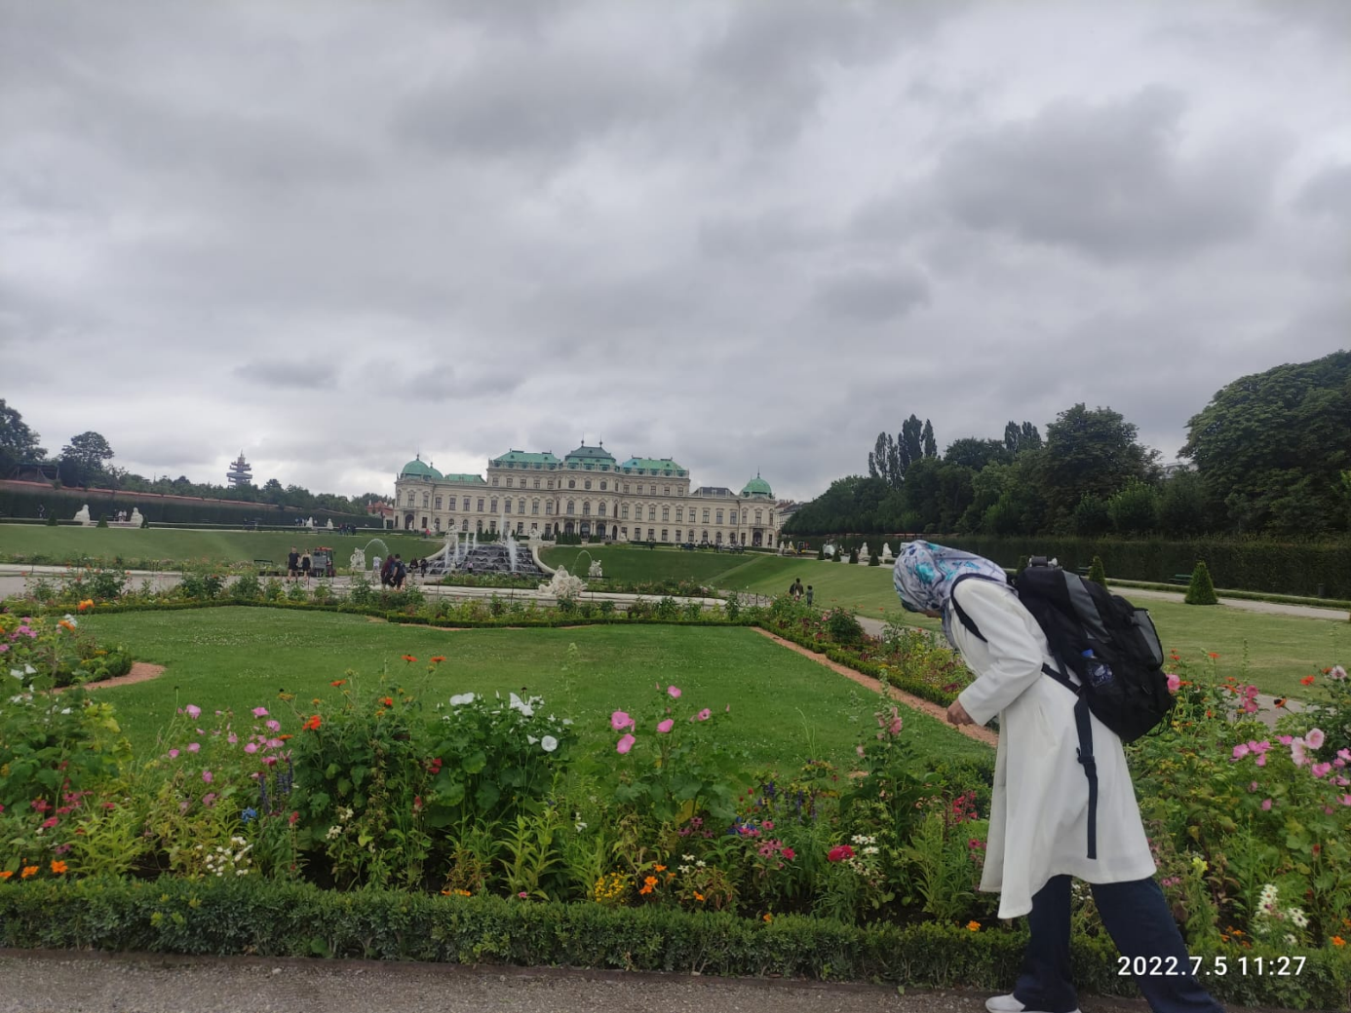
Moreover, I joined a project at Kahramanmaraş Sütçü İmam University, during which two American professors visited our institution. I provided assistance and support to them throughout their stay to ensure they met their needs and spent quality time together to foster productive collaboration.


Some advice for English learners
Thinking about my journey, I can give some recommendations for language learners. Feel free to adapt them and ignore those that don't work for you:
- Accept English as an everyday language and start thinking about it all the time.
- Incorporate regular English study sessions into your routine, aiming for at least five minutes a day.
- Use the Duolingo application (or any other of that kind) to enhance your language learning experience; benefit from other internet-based applications like, for example, https://www.wordtaboo.com/
- Utilise books like “Reader at Work 1” for foundational reading at levels A1-A2. Subsequently, progress to “More to Read 1”, followed by “Reader at Work 2”, and culminate with “More to Read 2”.
- Start thinking about what you enjoy. Do it in English. For example, if you like reading, read in English. If you like chatting with your friends, speak in English. If you like listening to music, listen to English music.
- Use self-study books like the "English Grammar in Use" book from CUP for grammar.
- TED Talks, renowned for their clarity and eloquence, serve as an excellent tool for refining your English language skills. By actively listening to articulate speakers, you can enhance your vocabulary, comprehension, and overall communication abilities. Select talks with subtitles to aid in understanding, and gradually challenge yourself with more complex presentations as your proficiency grows.
- Be brave enough to speak; nobody will judge you. Speaking is the most difficult part of learning English and develops after the other skills. When you find a foreign person, immediately go and talk to that person. Even if finding foreign people in your country is complicated, don't be shy when you have an opportunity.
- Use an English-to-English language dictionary. Whenever encountering an unfamiliar word, diligently record it in your notebook. Try to transcribe the entire sentence in which the unknown word is operated.
- There is no perfect time to learn English, so do it now.

Please check the Pilgrims f2f courses at Pilgrims website.

Please check the Pilgrims online courses at Pilgrims website.

