Using Realia in the Language Classroom to Foster Creativity

Kevser Bolat, Türkiye

Kevser Bolat, an undergraduate student in the ELT Department at Kahramanmaraş Sütçü İmam University, Türkiye, has designed some lesson ideas that enrich the much too often coursebook-led instruction in English language teaching. She presents some of them in this paper. Email: asliib.944@gmail.com

Realia in the classroom

Realia are real objects to be brought in the classroom for some learning purposes. Realia are often used for teaching young children (e.g., to teach colours, forms or textures), but they can actually be used for learners of all ages and all proficiency levels. They bring authenticity to the classroom (simply because they are authentic), address kinaesthetic needs of learners and can be used as a starting point for learners to create stories around the object (British Council, n. d.; Mumford, 2005). In short, using realia may and actually should go beyond a sole description of objects. Here are some ways of using realia, tested in micro-teaching sessions and further developed after the sessions.

The box

A box like the one in the photo can be used to engage learners in storytelling. Put something in the box – something heavy or light, something that makes a sound when the learners shake the box – but make sure that the learners cannot open the box.

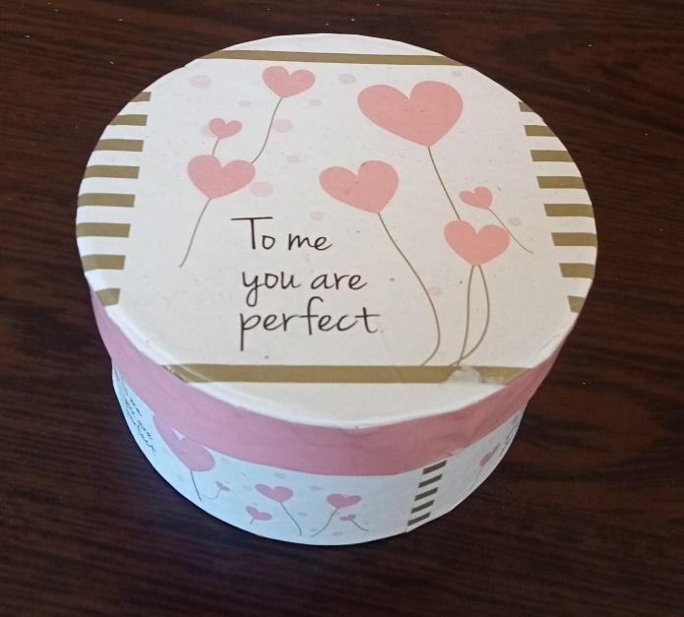

The teacher may prompt the learners by giving some questions and have the learners write more questions, for example:

- What is in the box?
- Who gave the box to whom? How old are they?
- What is the relationship between the two people? Have they recently met or have they known each other for a long time?
- How did they meet?
- How did the receiver of the box feel when s/he opened the box?

An alternative way would be to form groups (or pairs). Each group will write their own questions. The teacher may give the numbers of questions to be written. Then, the questions are passed to another group, and the receivers of the questions have to write the story behind the box.

In this activity, the following specific language points will be practised: question forms, simple past and past continuous, linking words (then, next, after the dinner).

The lipstick

Bring a lipstick to the class, maybe one with a rather unusual colour like the one in the photo.

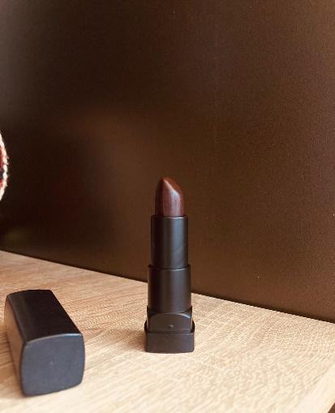

Ask the learners to describe it, and then have them collect adjectives (or other words) that characterise the person who uses the lipstick. Expected answers may be stylish, fashion-conscious, outgoing, gothic, melancholic (depending on the colour of the lipstick). Then tell the learners to give the person who uses the lipstick a name. After this, ask the learners to speculate on what the person will do this evening. This activity can be done individually, in pairs or groups, in writing or, preferably, in speaking.

In this activity, the following specific language points will be practised: modals for speculating (may, might, could), and agreeing and disagreeing (No, I disagree. I think she will…).

The pumpkin

A pumpkin like the ones in the photo can be used as authentic material in a lesson to develop cultural awareness as pumpkins are used for different purposes in different cultural contexts. They are food, decoration items, festival objects (carved lanterns in Halloween), and they are associated with fictional, often supernatural content, making them a part of popular culture. In multicultural classes, such an object may be a good starter to have learners inform their classmates about their own cultures, in my example about their ways of using pumpkins in their environment.

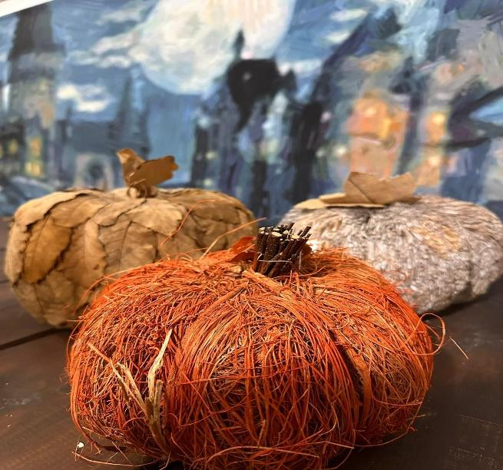

Have the learners touch, smell and lift the pumpkin. Then have them make a list of (known or assumed) purposes of using pumpkins and inform their peers. Additionally, this may lead into a mini-task in which the learners search on the internet to find additional information to be presented in class.

In this activity, the following specific language points can be practised: infinitive of purpose (In our country we use pumpkins to celebrate Halloween), and giving reasons (We eat pumpkin because it is tasty and healthy).

The buggy

The activity surrounding this unique piece of realia requires some preparation and suitable location, if possible a room next to the classroom. In this room, the learners will see a rather unusual object, however, covered under a blanket so that the object cannot be identified. The object might be an antique buggy:

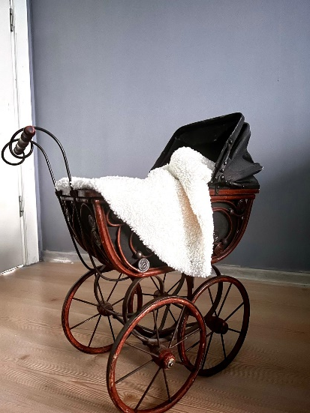

The learners are invited to speculate what is under the blanket. Then, the learner group goes back to their class, and (depending on the number of learners in the group), two to five students are selected to see the buggy. It is advisable that the teacher helps the students out with vocabulary (e.g., hand grip, canopy, wheel, wood, iron, fabric). That said, teachers will decide to use a buggy or any other realia when the content covered in the lessons before have relevance to the language necessary to describe the object.

In the meantime, the remaining students write true/false questions as it is their task to find out what the object is. The selected learners can only answer ‘yes’ or ‘no’, of course. After the learners have identified the buggy, it will be shown to the whole class.

Using antique or old-fashioned realia organically leads into a follow-up activity: Learners may be asked to compare the antique buggy with a modern buggy. This is best done when a modern buggy is brought to the class so that the learners can touch and move it as they did with the antique one. Learners are expected to produce sentences like, The modern buggy has smaller wheels than the antique one. The modern buggy is lighter than the old one. It was more difficult for mothers to move the old baby buggy.

In this activity, the following specific language points can be practised: yes/no questions; vocabulary related to materials, comparatives.

In the ocean – on land

Bring a starfish or seashell to the class. Allow your learners to touch it, to describe it and to report whether they have such items and where or who they got them from.

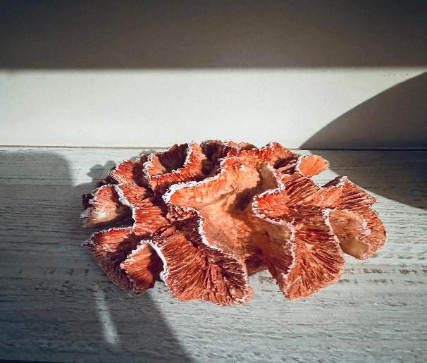

Now ask the learners to put themselves in the shoes of the starfish/seashell. This is likely to be attractive for young learners who have seen animated films like Finding Nemo. Either given by the teacher or developed in the learner group, questions will be created:

- Where did the starfish/seashell live? In the Pacific Ocean? In the Mediterranean Sea? …?
- Tell the learners to imagine that the starfish/seashell has eyes and can speak. Who did the starfish/seashell meet? What did they talk about? What did the environment look like? Was the water warm or cold? Did the starfish/seashell lead a happy life? …?
- How did the starfish/seashell come to the shore?
- Who found the starfish/seashell?
- Where does the starfish/seashell live now? What does the environment look like? Is the place warm or cold? Does the starfish/seashell live with a family? Does the starfish/seashell lead a happy life? …?

There are many ways of doing this activity – as a speaking or writing activity, and learners can draw pictures accompanying their texts. Learners can produce their story using the first person singular. The activity is suitable for individual and collaborative work.

In this activity, the following specific language points can be practised: past tense and present tense; ocean and sea-related vocabulary.

The desk

Select some items that you have or people may have on their writing desks at home. Here is an example.

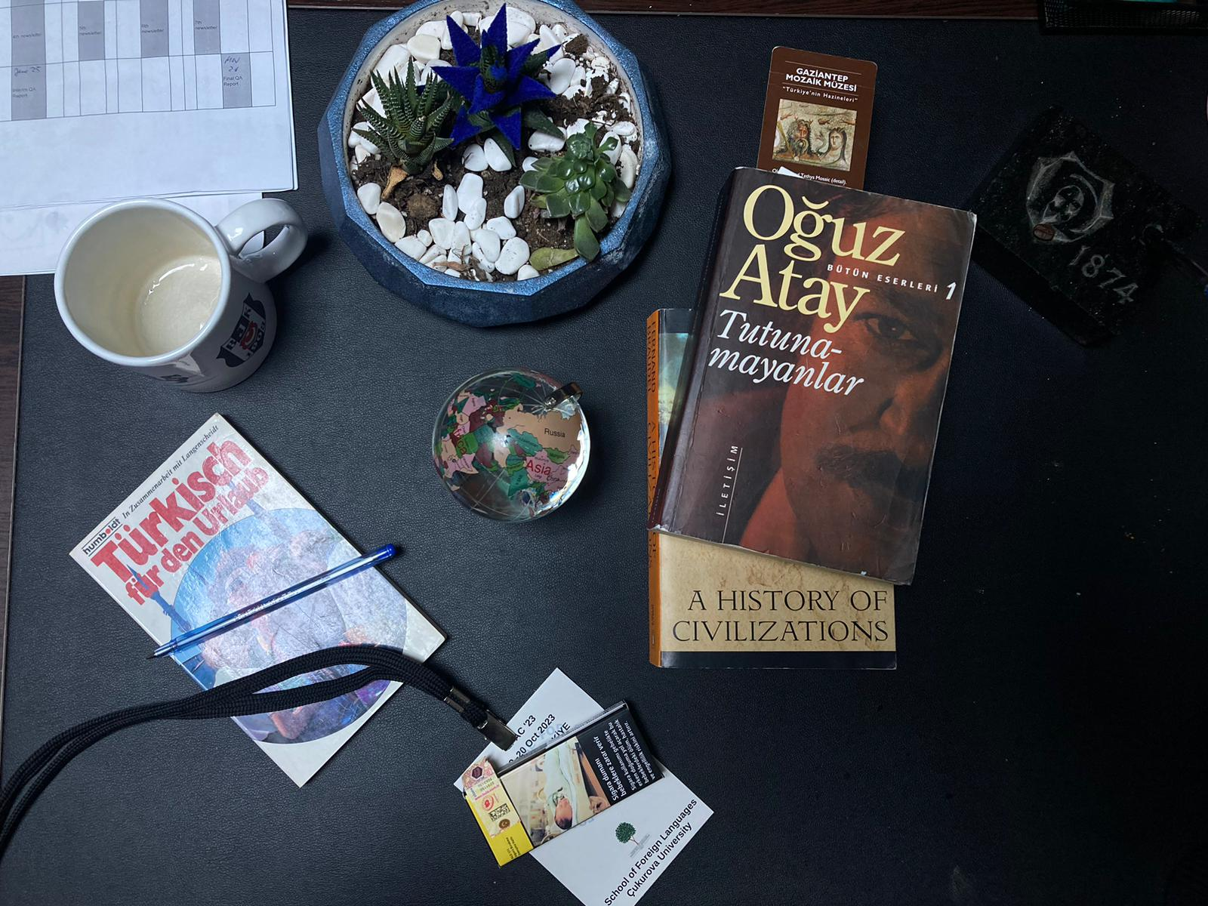

Give the learners opportunities to look at and touch the items, to flip through the books. You can practise here prepositions of place (e.g., There is a pen on the book). Now, ask the learners to give the person who possesses the items a name.

Draw the following table on the board:

10 years ago | now | in the near future
started to smoke  … | interested in history  … | travel to Turkey  …

Tell the students to write three or so statements in each column, preferably as phrases (as shown in the table). Learners will tell the class or in small groups about their person.

Extend this activity by having learners draw their own desk with items or bringing realia to the next class hour. Showing their items, they can describe their desks (On my desk, there is a notebook. Next to the notebook, there is a photo of my mum) and talk about their lives with reference to the objects.

In this activity, the following specific language points can be practised: past, present and future tenses; prepositions of place.

References

British Council. (n. d.). Realia. https://www.teachingenglish.org.uk/teaching-resources/teaching-secondary/activities/pre-intermediate-a2/realia

Mumford, S. (2005). Using creative thinking to find new uses for realia. The Internet TESL Journal, 11(2). http://iteslj.org/Techniques/Mumford-Relia.html

Please check the Pilgrims f2f courses at Pilgrims website.

Please check the Pilgrims online courses at Pilgrims website.

