Evaluation of Speaking Activities in a Local English Coursebook for 12th Graders: Interactional Patterns, Language Functions, Open and Closed Questions

Berra Nur Öztoprak, Yağmur Oktay, Hacer Göktaş, Tuğçe Erkınacı, Tuğçenur Caner, Türkiye

Berra Nur Öztoprak is an undergraduate student in the ELT Department at Kahramanmaraş Sütçü İmam University, Türkiye. With a passion for linguistic innovation, she wants to specialize in creating learning experiences with cutting-edge methods that will make English come alive for language learners. Email: berraoztprk@gmail.com

Yağmur Oktay is an undergraduate student in the ELT Department at Kahramanmaraş University, Türkiye. Advocating the idea that language learning is a natural, instinctive and vital phenomenon, she seeks an answer to the question of what learners and teachers need in this language learning process. Email: yagmuroktay698@gmail.com

Hacer Göktaş is an undergraduate student in the ELT Department at Kahramanmaraş Sütçü İmam University, Türkiye. As a pre-service teacher, she plans to conduct research to improve the English language teaching process for future generations. Email: hacergkts09@gmail.com

Tuğçe Erkınacı is an undergraduate student in the ELT Department at Kahramanmaraş Sütçü İmam University. Driven by a deep passion for language education, she aspires to become an English teacher in the future. Email: tugcerkinaci@gmail.com

Tuğçenur Caner is an undergraduate student in the ELT Department at Kahramanmaraş University, Türkiye. She looks forward to becoming an inspiring English teacher in the future and making English fun for children. Email: tugcenurrcanerr3134@gmail.com

Abstract

The aim of this study is to examine the speaking activities in a local 12th grade English coursebook for use at Turkish high schools in terms of interactional pattern, language functions and closed or open questions. This study was carried out with a qualitative method. In the analysis of the data, categorization was made using the content analysis technique. As a result, the coursebook was determined to be deficient in terms of interactional pattern and function diversity, while open and closed questions invite learners to discuss from a broad perspective in the speaking activities. It is suggested that coursebooks should be designed to include activities that will make students interactive, such as role play, to teach various functions of the language, and to provide instructions to encourage students to talk more.

Introduction

Communication and learning have a vital role in human life as humans are curious and want to live in society (Yaman, 2001). In the modern world, communication skills play a vital role and one must have mastery over reading, listening, writing and speaking skills to get success in their respective fields (Rao, 2019). So, in language acquisition, speaking is the most basic skill among these four key language skills. As English is a widely spoken and preferred language all over the world, acquiring the communication skills is necessary for learners to learn English. Thus, the most vital and effective way to learn these communication skills is to speak. One of the main reasons why speaking is essential in language learning is that it allows learners to express themselves and their ideas in the target language and to express what they think in an appropriate way. For this reason, it is inevitable that learners' perceiving speaking as a strategy for English rather than a goal that will provide them with great advantages and benefits in their language learning process and as language users.

Seeing speaking as a strategy for learning also means taking advantage of the benefits it brings and using speaking as a way to learn a language. The reason is that speaking provides learners with development in terms of vocabulary and grammar over time, and it ensures fluency and spontaneity in speaking. In this way, the language learning process accelerates and the learner's communicative skills, such as using idioms or slang in English, improve. This also contributes to the development of other language skills such as listening. Moreover, using speaking as a strategy is like learning a language by speaking, like a baby learning to speak, and this learning can be more permanent than other ways to learn English. For all these reasons, the importance of speaking in teaching English should not be underestimated and learners should be provided with benefits of speaking during the English learning process.

As the speaking activities are the essential activities that enable learners to communicate in the target language, when evaluating a coursebook, particular attention should be paid to speaking activities. So, the nature of the speaking activities in coursebooks has a vital role for learners and these activities must be designed based on some crucial components. These components include interactional patterns, various functions and the use of open and closed questions.

In this context, well-designed coursebooks take into account the fact that speaking activities require mutual interaction that enables students to be more successful in speaking skills. Functions such as asking for help, giving excuses and requesting allow speakers to facilitate effective communication and interaction with others. Using various functions of the language, the speakers gain the ability to effectively use language in a wide range of situations, improving their communicative competence in the target language. This draws attention to the importance of designing speaking activities in coursebooks in a way that prepares learners for real life and supports them to use the language for social and professional purposes. Open questions in the activities also prompt learners to think critically and generate their ideas in a detailed way, while closed questions concentrate on its output rather than on learners’ needs. All of these speaking elements are crucial when designing speaking activities in coursebooks.

In contexts where English is taught as a foreign language, like Türkiye, coursebooks serve as a map for teachers, and they are mostly followed in the lesson process. Therefore, it can be said that coursebooks play a key role in the learning process. However, there is a fact that learning English is not a success in Türkiye (Çolak, 2023; Demir Ayaz et al., 2019; Kızıldağ, 2009). In particular, Turkish learners are not proficient at speaking (Dağtan & Cabaroğlu, 2021). Although Türkiye is the 17th largest economy in the world, when it comes to certain indexes Türkiye consistently ranks very low on various measures of English language speaking. For example, in the 2013 English Proficiency Index (EPI), Türkiye ranked 41st out of 60, in 2017, 51st out of 72 countries. In 2016, the average total Test of English as a Foreign Language (TOEFL) score of both native Turkish speakers and residents of Türkiye was 78 over 120 (ETS, 2016) (Altan, 2017). So, it is possible to point out that many Turkish students are not even at the A1 proficiency level when they graduate from high school even though English teaching in Türkiye starts from primary school and continues until the last year of high school. The reasons for this may be related to lack of self-confidence and technology use or deficiencies in the education system, but as Khan and Taş (2020) stated in their study on speaking activities in international and local coursebooks, one of the reasons for not being successful in English is the local coursebook’s deficiency in terms of speaking activities. This could be because either the local coursebook underestimates what learners can do, or the international coursebook gives more flexibility to language teachers, as they can possibly choose which activity to do or leave out in the classroom thanks to having more activities at hand. This issue of expected learner workload could be the subject of further research to see whether having more activities at one’s disposal contributes to actual teaching practice (Khan & Taş, 2020).

From this point of view, examining the content of the coursebook is very important for teachers, especially in Türkiye. There are four key reasons why a thorough examination of the coursebooks is necessary. Nation and Macalister (2010) note that a coursebook must be evaluated to determine whether it: a) is suitable for a particular context of teaching and learning; b) meets the needs of the students; c) matches the goals of the course and suits the level of the students; and d) is interesting and uses effective techniques. In this context, it is important to evaluate speaking activities by considering whether they promote learners to speak interactively, which functions of language they consider and whether they enable learners to think from a broader perspective.

In this study, the local EFL coursebook Notifier (Çimen et al., 2023; henceforth: Notifier) used at Turkish state schools was analysed. The coursebook has been prepared for 12th graders and received approval for use in all public high schools in Türkiye. The focus of the analysis was an evaluation of speaking activities in terms of distribution of interactional patterns, functions and open and closed questions. The study sought to answer the following research questions:

- What interactional patterns are there in the speaking activities?
- What functions are covered in the speaking activities?
- Do the speaking activities encourage the learners to engage in elaborate speech?

The study

The coursebook
The coursebook analysed was Notifier, which is a local English coursebook prepared by the Turkish Ministry of Education for 12th grade students. In line with the state curriculum, the coursebook has been prepared for learners at B2+ proficiency level and the age range is 17-18 (Ministry of National Education, 2018). The coursebook provides ten units with self-assessment and portfolios at the end of each unit. It comprises multimedia materials, such as video and audio content that can be accessed over an interactive whiteboard. The goal of this coursebook is to enhance reading, writing, speaking, listening, grammar, and vocabulary.

Data analysis

For data analysis purposes, the coursebook was systematically examined to answer the research questions. For this reason, a framework was established to identify interactional patterns, functions and open and closed questions.

To start the analysis, all speaking activities in the coursebook were identified. For this purpose, the researchers examined the first two units together. All speaking activities were included but speaking components in portfolios and self-assessment were excluded from the data analysis. Then, the researchers analysed the remaining units and met in regular sessions to compare their results and agreed on a result in case of disagreement. The same procedure was followed when analysing the identified speaking activities in terms of interactional patterns, functions and open and closed questions. To this end, the researchers engaged in content analysis (White & Marsh, 2006). Deductive coding was applied, i.e. predetermined frameworks as explained in the following sections were used.

Analysis of interactional patterns

Interaction refers to the cooperative exchange of concepts, thoughts, emotions and the like between people, to convey messages. It has been well explained in theories dealing with human communication showing that language is essential to negotiate meaning to communicate ideas or understand messages accurately (Brown, 2001). Therefore, it is vital for students learning another language to engage in interaction in speaking activities in order to communicate, exchange ideas, get feedback, listen and understand while speaking the language as they do in real life. Oral real-life communication is realised through speakers engaging in monologues, dialogues or exchanges with two or more interlocutors. Given the importance of interaction to facilitate language learning, a considerable amount of speaking activities in which learners speak with an interlocutor is desirable. Against this backdrop, the speaking activities were analysed to identify the distribution of the three interactional patterns individual, pair and group work. Speaking activities that were explicitly denoted as pair work were coded as pair work; speaking activities that were explicitly denoted as group work were coded as group work; all other activities were coded as individual.

Analysis of functions of language

Functions refers to the purposes speakers have when they engage in language production irrespective of whether they produce speech or written texts (CEFR, 2001, p.125). The scholarly literature is characterised by a variety of different labels to identify and describe functions. The CEFR (2001, p. 126), for example, lists sample functions:

- giving/sharing opinions
- giving information/example
- defining/describing/interpreting
- making predictions/claims
- giving reasons/supporting opinions
- making suggestions
- relating/retelling past events
- accepting/refusing an offer
- comparing
- asking questions

Such attempts of categorising functions helped the researchers to identify functions in the speaking activities of the coursebook examined.

Analysis of open-closed questions

Open-ended questions stimulate students' background information and enable them to think from a broader perspective, because there is no definite response to them. In short, the more open a question used in instructional practice is, the more cognitively challenging it is (Tomlinson & Masuhara, 2018). Closed questions, on the other hand, are questions that require a simple "yes" or "no" answer or have a clear and short answer. A question that does not cause or encourage students to think or discuss. To this respect, open-ended questions in speaking activities enable students to think and discuss in the classroom by using their speaking skills and get interacted. After inspecting the questions used in speaking activities in Notifier, the researchers decided to distinguish between three categories of questions:

- The question requires only a short answer.
- The question requires an answer of moderate length.
- The question invites learners to discuss the issue from a broad perspective.

Results and discussion

In the following sections, the results are presented according to the three components examined in the study. First, the distribution of interactional patterns is shown. Then, the distribution of functions is presented. Finally, the results concerning the distribution of open and closed questions are shown. Results are discussed.

Interactional patterns

In the Notifier, there are 47 speaking activities and each activity has clearly one of the interactional patterns which are group, pair or individual. The identification of the distribution of interactional patterns in the speaking activities was one of the aims of this study. Each of the interactional patterns’ distribution is shown in Figure 1.
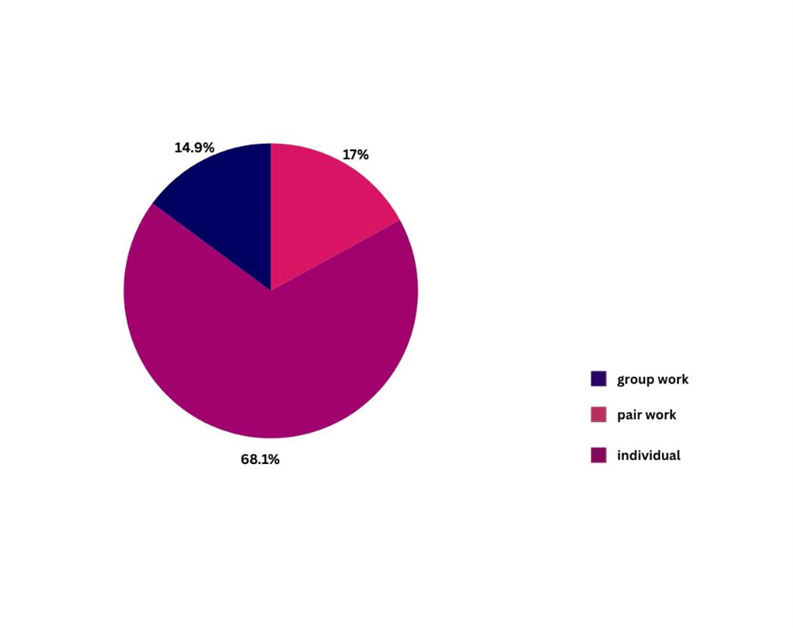
Figure 1. Distribution of group work, pair work and individual work in the speaking activities

As Figure 1 shows, more than half of the speaking activities were individual work (32). The second largest group was pair work (14), while the rest of the activities were group work (6).
An example for an individual speaking activity is shown below:

“Discuss the following questions about your favorite musical instrument.”
- What musical instruments do you like best?
- What do you like best (design, sound, usability, etc.)?
- Do you know what instrument family (strings, percussion, etc.) it belongs to?” (Notifier, 2023, p. 12).

The analysis of the sample speaking activity in the coursebook provides a valuable insight into how insufficiently these activities enhance the dynamic language acquisition. Activities that encourage group and peer interaction play a significant role in the language learning process. Activities such as pair or group work enhance the learners’ speaking skills enormously since the learners get an opportunity to share their thoughts and ideas in a collaborative atmosphere (Topçu & Başbay, 2020). On this ground, the low presence of social interaction in the target coursebook’s speaking activities suggests that a favorable attitude of the coursebook cannot be attained.

Distribution of functions

Figure 2 shows the number of various functions in speaking activities.
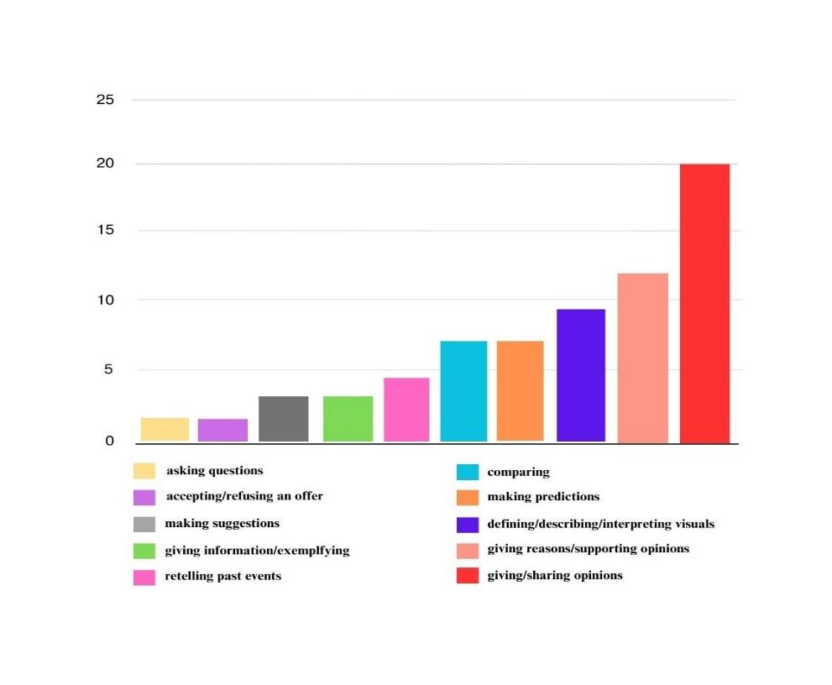
Figure 2. Distribution of functions in speaking activities

Figure 2 shows that giving/sharing opinions is most frequently used (20 times). With 11 instances, giving reasons and supporting opinions follow. Defining, describing, and interpreting visuals are also used nine times. Both making predictions and comparing are used six times. Examples and information giving as well as relating past events and retelling stories are used four times. Making suggestions is used three times. Additionally, asking questions, and accepting or refusing offers are less frequent, and used one time each.

The coursebook does not fully meet the requirements of speaking skills directed to the acquisition of functions that are essential in the language learning process. In terms of functional evaluation in the speaking activities, it is clear that the Notifier does not incorporate diverse functions. As shown in Figure 2, types of functions identified in the speaking activities are largely based on sharing and supporting the ideas. Speaking activities based on this function encourage students to think critically and present their ideas often showing remarkable fluency. As Liaw (2007) stated, regardless of their proficiency levels, students should be exposed to activities in which they can analyze the information, discuss their opinions and produce something using the language that is appropriate to their level since critical thinking should be enhanced continuously.

However, there are activities that foster the teaching of functions. For example, a speaking activity that uses visuals to train the function of speculating (Notifier, 2023, p. 46) is used in the coursebook. In the activity, students have to speculate about future activities shown in visuals. This activity fosters students’ critical thinking abilities because the learners have to analyze and defend their ideas. However, it is essential that exposing the learners to a variety of functions equips them with the skills needed for different language situations that they may encounter in real life. Regarding the activities in the coursebook, the target coursebook was found weak in terms of the functional variety.

Distribution of the open and closed questions

The distribution of open and closed questions is illustrated in Figure 2.

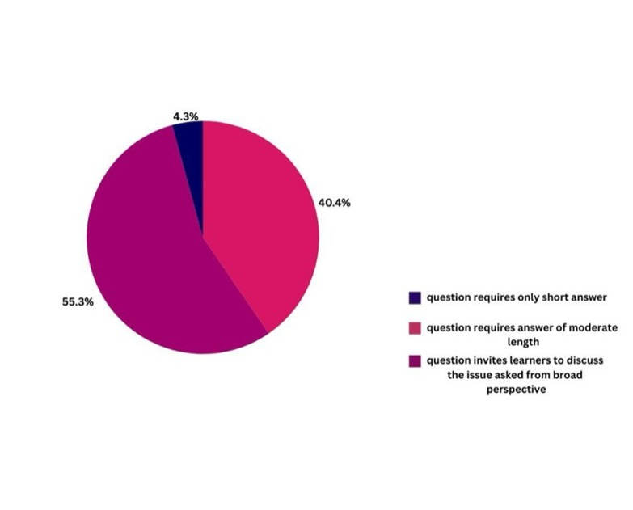
Figure 3. Distribution of open and closed questions in the speaking activities

As seen in Figure 3, more than half of the speaking activities include questions which invite learners to discuss from a broad perspective (26), while 40 percent of the activities include questions of moderate length (19). Lastly, there are only a few activities (2) that include questions which require a short answer.

An implication of this finding is that a learning approach in which critical thinking skills and comprehensive understanding are maintained is in effect in the Notifier, short answer questions that have traditionally been thought to assess factual recall and lower levels of response (CEFR, 2001, p.96) do not dominate.

For example, in an activity (Notifier, 2023, p. 103), the students are asked to evaluate six electronical second-hand devices in terms of price and features in order to decide which one is worth buying. Therefore, this activity constitutes a good example in terms of directing students to discuss debatable issues through open questions. This example is likely to provide a more effective learning experience by allowing students to use their critical thinking skills at different levels.

Conclusion

In this coursebook evaluation, the speaking activities included in a 12th grade local English coursebook were analysed in terms of three criteria. The study revealed that the speaking activities in the local coursebook prepared by the Ministry of National Education can be optimised for the benefit of students to improve their speaking skills.

The coursebook can be made more attractive for the target group because, as shown in the results, the speaking activities in the coursebook mostly expose learners to individual work without getting interacted. In this respect, the learners are deprived of opportunities such as improving their communication skills, exchanging ideas and receiving feedback. Also, the diversity of functions covered in the coursebook can be enhanced as mainly some particular functions are integrated, which does not prepare the target learners to use the language in a variety of communicative contexts. Nevertheless, most of the questions are open questions, that is, they are questions that encourage students to think and speak from a broad perspective.

In order to enhance the quality of the book, it is feasible for the coursebook writers to include speaking activities that will give students the opportunity to create an environment where they can interact with each other, rather than including individual tasks. Accordingly, before designing the coursebook, the coursebook writers should conduct more in-depth investigation to design activities in which students can role-play and work more in pairs or groups. It could also be worthwhile to investigate the relationship between materials and communicative competence from the perspective of students, whose opinions may reveal to what extent they think using local coursebooks contributes to their communicative language ability (Taş & Khan, 2021). Based on the data obtained from this investigation, the coursebook should be redesigned for the benefit of the students' needs. Another stage that needs to be planned in order to enhance the quality of the coursebook is the diversification of language functions based on the CEFR framework to avoid covering the same functions within activities repetitively.

References

Altan, M. Z. (2017). Globalization, English language teaching and Turkey. International Journal of Languages’ Education and Teaching, 5(4), 764-776. http://dx.doi.org/10.18298/ijlet.2238

Brown, H. (2001). Teaching by principles: An interactive approach to language pedagogy (2nd ed.). Longman.

Council of Europe (CEFR). (2001). Common European framework of reference for languages: learning, teaching, assessment. Cambridge University Press.

Çimen, F.& Tiğin, B. & Çokçalışkan, A. & Özdemir, M. & Cellat, S. (2023). Notifier: English 12 coursebook. Milli Eğitim Bakanlığı Yayınları.

Çolak, İ. (2023). ‘‘Bir lisan, bir insan, iki lisan, iki insan?’’ Observations and reflections of an undergraduate student on the situation of ELT in Turkey. Humanising Language Teaching, 25(4). https://www.hltmag.co.uk/aug23/bir-lisan-bir-insan-iki-lisan-iki-insan

Dağtan, E., & Cabaroğlu, N. (2021). Status of English-speaking skills in Turkish ELT departments: A nationwide survey. Eurasian Journal of Applied Linguistics, 7(1), 359–382. http://dx.doi.org/10.32601/ejal.911454

Demir Ayaz, A., Özkardas, S., & Özturan, T. (2019). Challenges of English language teaching in high schools in Turkey and possible suggestions to overcome them. Eurasian Journal of Applied Linguistics, 5(1), 41-55. https://doi.org/10.32601/ejal.543778

Khan, Ö., & Taş, T. (2020). Can local coursebooks in Turkey be an alternative to their global counterparts for the teaching of speaking? Novitas-ROYAL (Research on Youth and Language), 14(1), 1-12. https://novitasroyal.org/volume-14-issue-1-april-2020/#

Kızıldağ, A., (2009). Teaching English in Turkey: Dialogues with teachers about the challenges in public primary schools. International Electronic Journal of Elementary Education, 1(3), 188-201. https://www.iejee.com/index.php/IEJEE/article/view/274/268

Liaw, M. (2007). Content-based reading and writing for critical thinking skills in an EFL context. English Teaching & Learning, 31(2), 45-87. https://lib.ctcn.edu.tw/%E4%B8%BB%E9%A1%8C%E6%99%BA%E5%BA%AB/%E6%80%9D%E8%BE%A8%E5%89%B5%E6%96%B0%E7%9B%B8%E9%97%9C%E6%96%87%E7%8D%BB/%E7%9B%B8%E9%97%9C%E6%96%87%E7%8D%BB/Content-Based%20Reading%20and%20Writing%20for%20Critical%20Thinking%20Skills%20in%20an%20EFL%20Context.pdf

Nation, I. S. P., & Macalister, J. (2010). Language curriculum design. Routledge.

Rao, P., S. (2019). The importance of speaking skills in English classrooms. Alford Council of International English & Literature Journal (Aci̇elj), 2(2), 6-18.

Taş, T., & Khan, Ö. (2021). Complying with the English language curriculum in Turkey: Speaking activities in local and international coursebooks: International Journal of Curriculum and Instruction, 13(3), 3495–3512. https://ijci.globets.org/index.php/IJCI/article/view/607/419

Tomlinson, B., & Masuhara, H. (2018). The complete guide to the theory and practice of materials development for language learning. Wiley Blackwell.

Topçu, E., & Başbay, M. (2020). The impact of collaborative activities on EFL learners’ speaking anxiety levels and attitudes. Çukurova University Faculty of Education Journal, 49(2), 1184-1210. https://dergipark.org.tr/tr/download/article-file/860289

White, M. D., & Marsh, E. E. (2006). Content analysis: A flexible methodology. Library Trends, 55(1), 22-45. http://dx.doi.org/10.1353/lib.2006.0053

Yaman, E. (2001). Doğru, güzel ve etkili konuşma sanatı, sözlü anlatım [The art of correct, beautiful and effective speech, oral expression]. Gazi Publishing.

Please check the Pilgrims f2f courses at Pilgrims website.

Please check the Pilgrims online courses at Pilgrims website.

