Letter 1

 | Mon, Jul 15, 11:45 AM
  Walter Pichler
To Hania

Mein neuester Titel ist online!

https://www.youtube.com/watch?v=qz3DINh3sH0

LG Walter

Attachments area
Preview YouTube video Recollections
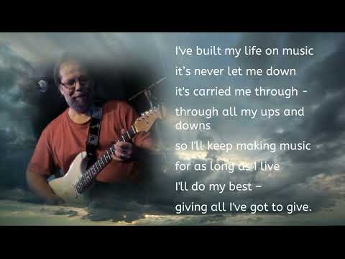
Congratulations Walter

Letter 2

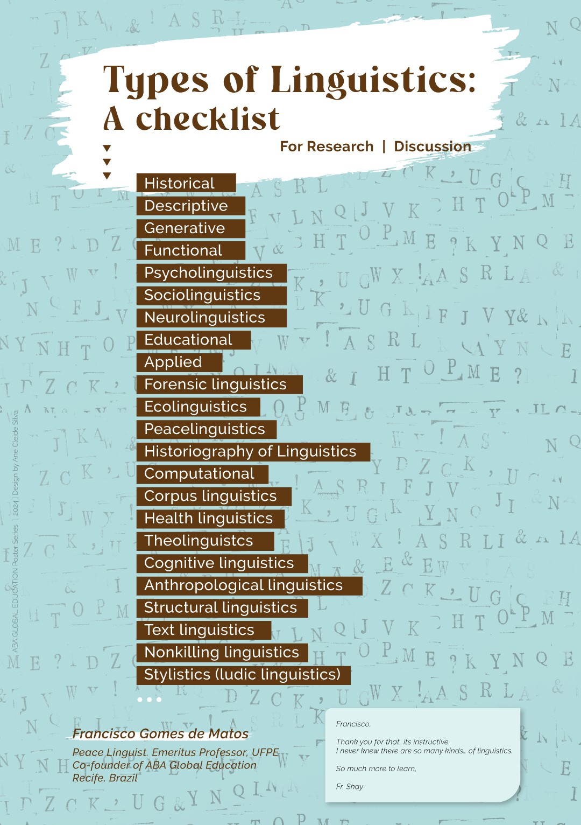

Letter 3
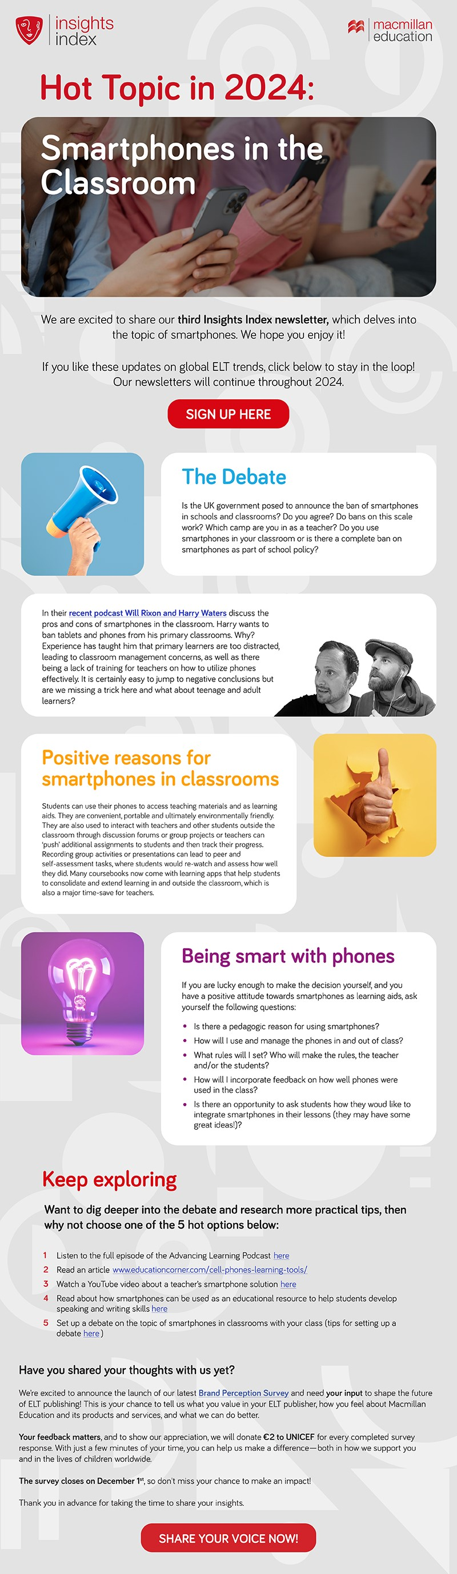
Link to Newsletter
Share Your Voice

Letter 4


Introducing our new free webinar series!

The MET Spotlight Series from Modern English Teacher

The MET Spotlight Series shines a spotlight on key topics we’ve explored in Modern English Teacher. In these webinars, our fantastic MET contributors will explore their chosen topic in more detail, and share their expertise alongside practical tips, useful ideas to try and more.

Sign up is free for everyone, regardless of whether or not you have a subscription to MET! We are delighted to announce the first in the series below, with regular contributor and MET blogger Anna Hasper. Find out more and sign up for free below.

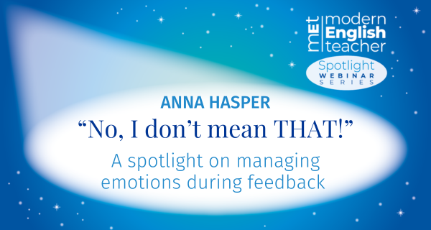

“No, I don’t mean THAT!”
A spotlight on managing emotions during feedback

Anna Hasper | Wednesday 23rd October

According to Hattie (2008), feedback is one of the most powerful performance moderators. Whilst providing feedback to learners – whether it is language learners or novice teachers – validates their efforts, constructive feedback is crucial for any learner to further develop their skills.

However, receiving constructive feedback may be challenging to accept and thus trigger negative emotions. Interestingly, teachers and teacher-trainers are mostly trained in what to give feedback on, focusing on the cognitive dimension, while how to manage emerging emotions during feedback, the affective dimension, receives very little attention (Richards, 2020) in teacher education.

In this interactive webinar, we will examine the concept of feedback in a classroom setting and its importance before exploring various responses. We will then focus on some practical strategies to proactively manage learners’ emotions in order to safeguard the emotional well-being of both those receiving and providing feedback.

Inspiration will be taken from Anna’s article in the January/February 2024 issue of MET: Managing emotional wellbeing during group feedback.

Sign up for free here

