

Business Impact. Business English Modules from DELTA Publishing
In today's business world, flexibility is key – and Business Impact delivers exactly that. This modular business English course is designed for professionals who want targeted, practical language training that fits their needs and schedule.
Each module focuses on a core area of business English, allowing you to choose the areas most relevant to your learners' goals. The adaptable structure fits perfectly for in-company courses and tailored learning paths.
Business Impact is a unique modular business English course, available in 6 books on two levels and/or individual digital modules. It's specifically aimed at business professionals and suitable for all business English courses, in particular in-company courses. The 3 modules of each book have a clear focus on one of the core areas of business English. The course offers maximum flexibility in content and structure, to suit students’ needs and time available.
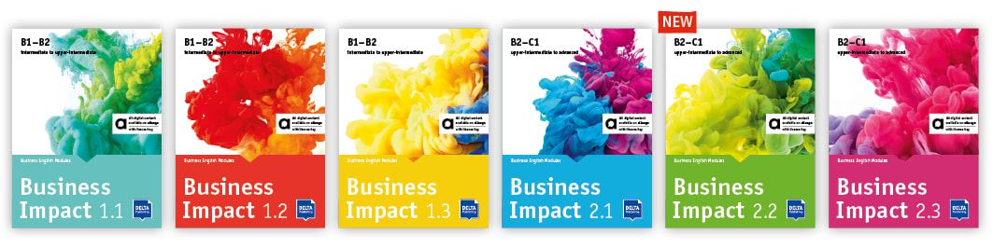

Maximum flexibility in business English

  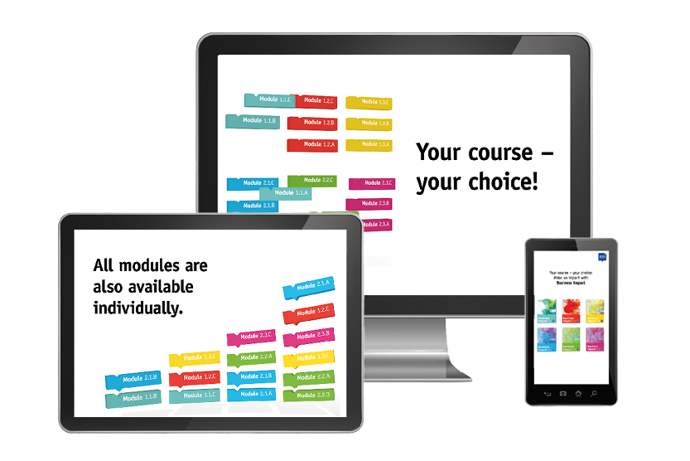
  Watch the video and find out more!
  Watch now

Business Impact 1.1
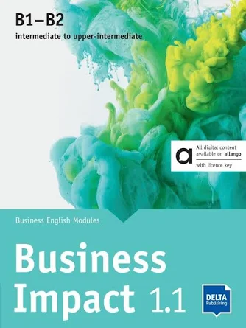
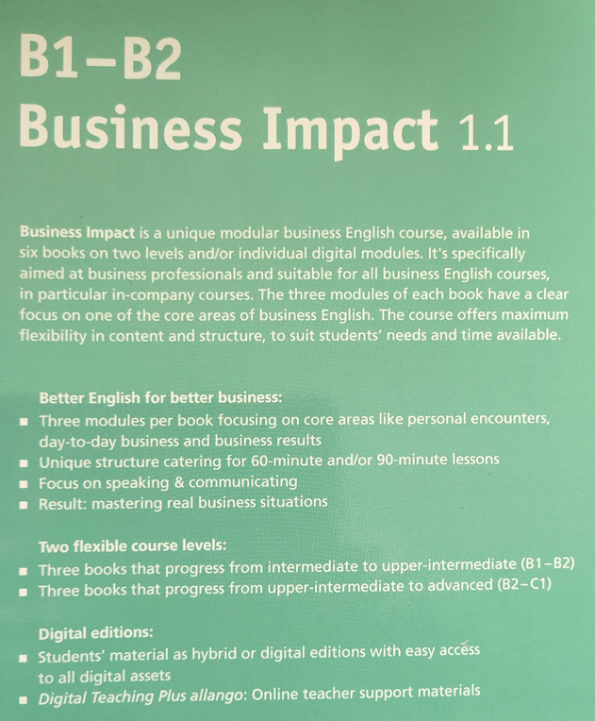
Stephanie Ashford, Jason Humphreys, Robert Kirstein, Louis Rogers
Business Impact 1.1 B1-B2 - Digital Edition allango
Licence key (teachers/students, 24 months)
Business English Modules 1.1.A, 1.1.B, 1.1.C
NP10050107000

Digital allango B1 - B2
What is allango?
What is allango?
allango (derived from "all languages") is your new platform for easy language learning and teaching. With the browser-based solution from Ernst Klett Sprachen www.allango.net, you can, among other things, access digital editions directly and edit these as you wish.
In addition, allango offers you a large selection of digital supplements for your book and much more! Discover new possibilities that will make your lesson organisation much easier.
More information here
Watch video tutorials here
The Digital Edition gives you access to the digital form of the book on the allango learning platform - with the digital media content you need right at your fingertips.
Benefits to you of the digital version:
- Suitable for all end devices, such as smartphone, tablet or PC
- Locate, search, browse and bookmark the pages in the book quickly and accurately
- Enhanced display settings with zoom function
- Retrieve specific media content such as audio or videos for each page
- Comprehensive toolbar with a range of editing options such as highlight, comment, underline and hide
- Save multiple versions of personal drafts for the Digital Edition
- Digital Edition incl. media content can be used online and offline
- Manage content in personalised lists and much more

All editions Business Impact 1.1
Hybrid edition allango (book incl. digital edition)
Digital Edition allango for teachers and students

Business Impact 1.2

  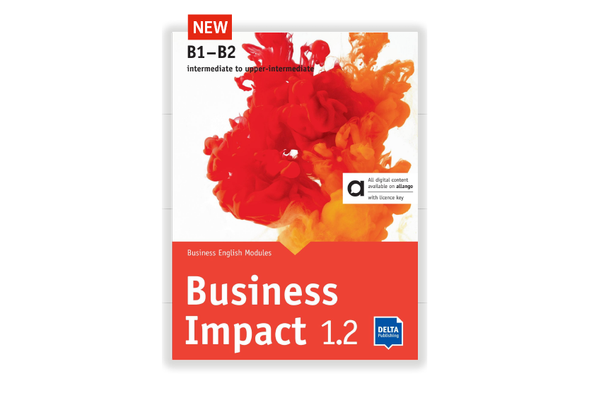
  Modular structure with 3 modules per book focusing on the core areas of business English
  Maximum flexibility for 60 and 90 minute lessons
  Focus on speaking & communicating in real-life business situations
  Test for free

Short Review
by Hanna Kryszewska, Poland

So far I have looked at Business Impact 1.1. The book itself is divided into 3 Modules: Module A -small talk, Module B – meetings, and Module C – numbers, figures, goals and plans. The language input is well structured but rather at Intermediate level not Upper Intermediate level. However we must remember this is the beginning of a six-part course and surely there will be progression. Also, one might think that a starting point of a course in terms of business content it seems pretty basic, too. Yet, this is a good and light start of the course. It is

The approach is very practical and hands on with main focus on phrases, lexis and language functions. These are introduced through short texts (one pagers) and audio recordings. There are sections on essential phrases, and elements of writing. Each module consists of 6 sessions. The theme of the module is developed harmoniously and ‘drives well’. There are also small surprises called “Energizers’- short video clips e.g. in Module 1, Session 1 it is a relevant fragment from “Little Britain”.
At www.allango.co.uk the DELTA learning platform you will find a digital version of the book, additional materials for the students, audio recordings etc. The format of the book makes it a perfect choice if you want to use modern technology and your lessons, and if you teach online, which I do.
Additionally, exclusively for teachers (at extra cost) you can access Digital Teaching Plus which enables you to organise your classes even more time-efficiently and easily. It offers you practical additional content for the Digital Edition – page-specific and accessible offline.

