Love Our Planet from Usborne

found online and reviewed by Hanna Kryszewska, Poland

One evening, I was looking for good and suitable materials to teach my grandchildren. This is not to say that when I teach other children I don’t look for good materials. It is just that these days the only kids I teach are my grandchildren and the experience is different from teaching children some time ago. Firstly, they are my grandchildren so there is an emotional factor, secondly, I teach them one-to-one, and thirdly I teach them online as they live 750 km away. So, the term ‘good’ materials might mean here materials ‘suitable’ for my purpose.

Here I found a treasure trove to dip into and select from. All around the ECO theme. I have always liked Usborne materials, and I always got a lot of inspiration from them. Just the very titles show a great variety and range of topics. The visual impact, as always, is very appealing and varied. What a find!

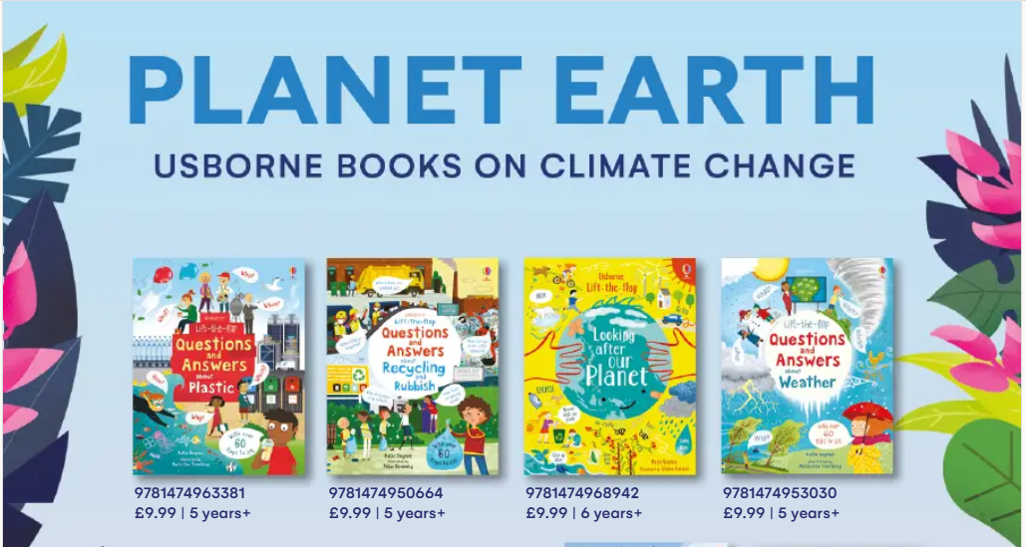
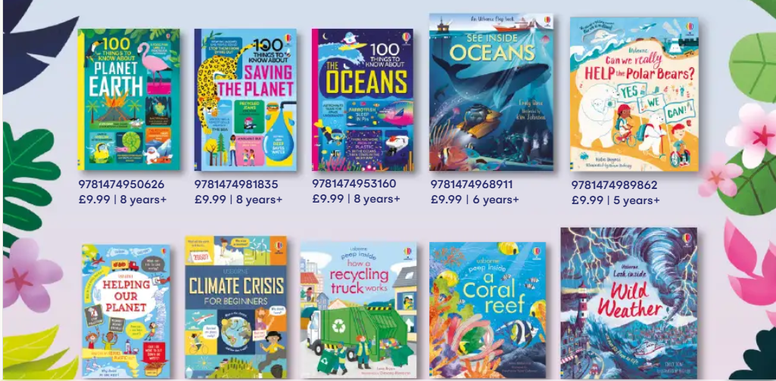
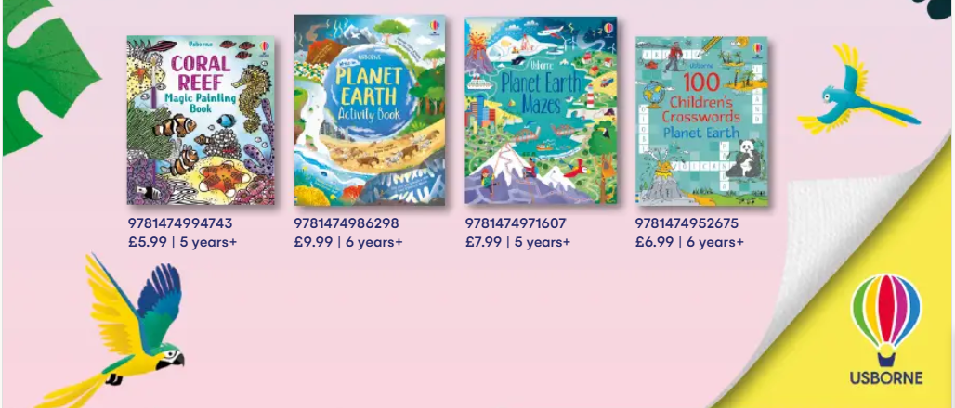

After the initial excitement I realised that they are aimed for native kids, and not EFL classes. But my excitement did not wane. Very quickly I saw ways to adapt the materials or get inspired by them. Also, I saw a great CLIL opportunity. Besides the worksheets can be used with older kids – I would say in any primary EFL class.

Take a peek yourself - the material was downloaded for free.

Coming soon! Please check the Pilgrims in Segovia Teacher Training courses 2026 at Pilgrims website.

