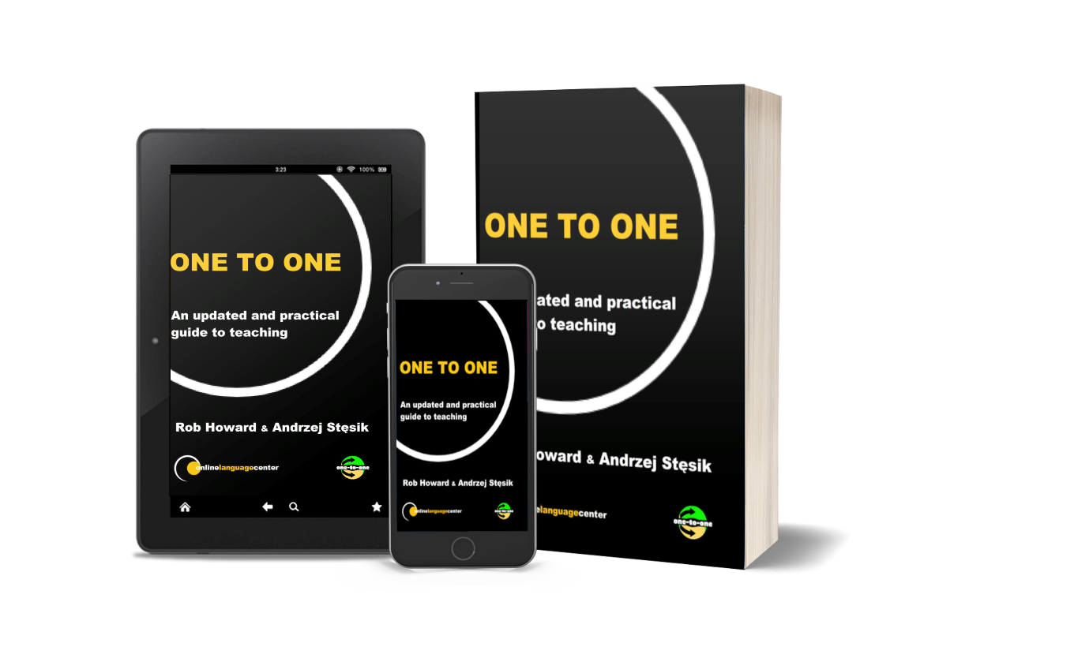One-to-One: An Updated and Practical Guide to Teaching. A New Addition to Your CPD Collection

review by Oksana Hera, Ukraine
Oksana Hera is a business English and intercultural communication trainer from Lviv, Ukraine. Her interests lie in enhancing in-company training and helping professionals to improve their communication.

Editorial
The review is reprinted with permission from IATEFL BESIG Business Issues, February 2024, Issue 111.

About the authors

Andrzej Stęsik is well-known both as an English communication trainer and methodologist not only in Poznań but throughout Poland and beyond. A specialist in Business English training, he has been pursuing his great passion for the English language for over 30 years. For many years he has been conducting training for Business English teachers in Poland and abroad and has been presenting at international conferences where he often focuses on the topic of organic teaching programmes in individual training. He served on the board of the IATEFL Business English Special Interest Group (BESIG) for nine years.

Rob Howard is the owner of the Online Language Center and Business Language Training Institute. He is a teacher, trainer, ELT author and frequent worldwide speaker on Business English, Teacher Development, Entrepreneurship, Marketing, teaching online, and using or not using technology and AI. He is the current IATEFL Poland president, past Joint Coordinator of the IATEFL BESIG and IATEFL BESIG Web and Online team, founder of the Independent Authors & Publishers and EFLtalks and has presented for Gallery Teachers Masterclasses, iTDi TOEFL training, ELI Publishing, Macmillan Publishers, and IATEFL BESIG, LTSIG, MAWSIG, TDSIG, and YLTSIG.


When was the last time you were reading a book, realizing that it was the one you had lacked in your professional development for a long time? If you have ever done at least a couple of one-to-one lessons with your students and clients, you may find this one of particular interest.

‘One-to-one: An updated and practical guide to teaching’ by Rob Howard and Andrzej Stęsik does just what it promises in the title. It guides you through a range of questions you may have wondered who to ask on your one-to-one teaching journey. This guidebook consists of 12 chapters highlighting the essential elements of organizing your professional routine as a freelance one-to-one teacher.

It opens with a brief yet practical overview of possible advantages and disadvantages of teaching English one-to-one and then delves into clarifying the authors’ view of the key terminology and concepts used in the industry. If you are confused about a variety of terms and titles available to those working one-to-one, Andrzej and Rob promise that after reading this book “you should have a better understanding of what role, which niche, and what name to give yourself as an educator” (Howard & Stęsik, 2023, p.19). And they do set the standards high here.

Reading through the story developing in the following chapters, you explore the various stages of organizing one-to-one cooperation with the learners, from the first point of contact, compiling the learner's profile, and conducting the needs analysis which meets the requisite requirements to designing a course with clear objectives, and delivering the result.

Chapter six uncovers some of the most delicate issues in current ELT practice, such as accent-related training, touches upon the skill of productive arguing, and unveils the secret of what to do “to be able to not prepare your classes” (Howard & Stęsik, 2023, p.70).

Moving on, the authors approach feedback in teaching by providing examples of what to mention, how to do it effectively and appropriately, as well as by sharing a template for structuring the information you collect and share when at the feedback stage.

To give you a wider perspective of teaching one-to-one, the next chapter is dedicated to the practicalities of working online. It covers a wealth of recommendations on how to organize your workplace, which equipment may be required or helpful, and some advice on how to connect with your learners better no matter where they are based.

Chapter nine is dedicated to the business side of one-to-one cooperation. You will find ideas on how to prepare your contract, what pricing strategies to choose and how to ensure you have enough clients to work with, In the next chapter, you are offered a myriad of case studies where Rob and Andrzej share their thoughts on how they approached the needs of their learners and helped them reach their full potential in communicating in English internationally.

Having been active in a number of professional organizations and having extensive experience of volunteering for them, Andrzej and Rob give an overview of teaching associations you may want to explore to boost your professional development.

And if you are a lucky owner of this guide, you will notice that the authors have modestly placed their own stories at the very end. I encourage you to read Chapter twelve first. This will give you a clearer idea of where the authors’ inspiration for all those lessons ideas come from.
References
Howard, R, Stęsik, A. (2023). One-to-One: An updated and practical guide to teaching. Online Language Center

Also by the authors

Looking for activities for one-to-one? Looking for content? Do your students want a coursebook? No time to make materials? Sick of AI generated lessons?
Have we got the solution for you! Activities for Speaking Vol. 1 has 50 speaking activities ready to use in the classroom.
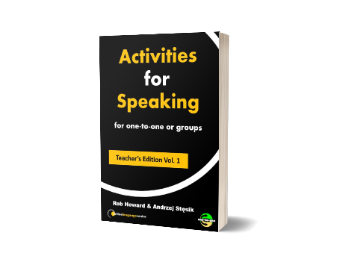
Just buy the Teacher’s edition once, send your students the link to buy the student book, and you’re ready to assign them pre-class material for 50 weeks that will get them thinking, engaged, and speaking.

Coming soon! Please check the Pilgrims in Segovia Teacher Training courses 2026 at Pilgrims website.

