Professors at Play

reviewed by Hall Houston, Taiwan
Hall Houston teaches adults and university students in Taipei, Taiwan. He has a Master’s degree in Foreign Language Education from The University of Texas at Austin. In 2024, he received the Trinity CertPT from Pearson. He is the author of several books about language teaching, including The Creative Classroom, Provoking Thought, and 101 EFL Activities for Teaching University Students. His articles have appeared in Modern English Teacher, IH Journal, EFL Magazine, TESOL Connections and IATEFL Voices. He has delivered presentations and teacher training sessions for British Council and Cambridge English in Taiwan.

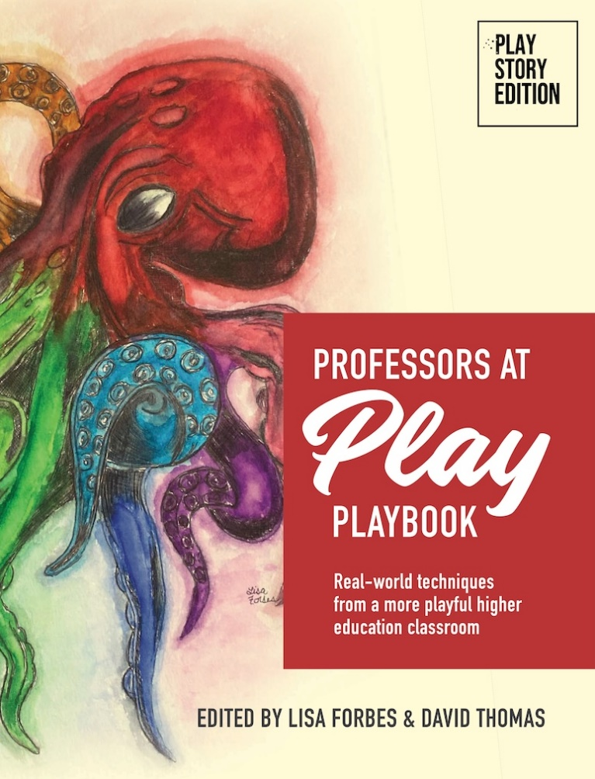
Professors at Play PlayBook
Professors at Play AI PlayBook
Professors at Play Online PlayBook
edited by Lisa Forbes and David Thomas
https://professorsatplay.org/playbook/

A few decades ago, in the 20th century, I was a university student. Most of my professors taught their classes in a teacher centered, lecture focused manner, which meant that most of my classes consisted of listening to the professor and trying to take notes. What was absent was any elements of active learning, group work or anything that was student centered. Later on, as I began my teacher training, I began to reflect on what was missing in my undergraduate courses. In retrospect, I wonder what my undergraduate experience would have been like if my professors followed a “playful pedagogy”.
What is playful pedagogy? It’s a way of teaching that involves playfulness, creativity and fun. It’s the subject of the book I will be reviewing here.
The thesis of this book, Professors at Play PlayBook is that university professors and lecturers can make their classes, regardless of the course subject, more active and more playful for the students, without sacrificing the importance of the academic context.
This book is the creative work of two professors at the University of Colorado at Denver. Lisa Forbes is an Assistant Clinical Professor who trains people to be professional licensed counselors. David Thomas is a Professor in the Department of Architecture, as well as the director of online services. Their goal is to promote playful pedagogy in adult higher learning.
Professors at Play Playbook (2022) is a compendium of different ideas from professors in vastly different fields, united by the theme of playfulness.
The book consists of a foreword, an introduction by the authors, and seven chapters. Most of the book consists of techniques from professors in many different fields that relate to the book’s thesis. The techniques are written in an activity format, not too different from the resource books for teachers published by Cambridge University Press and Oxford University Press.
In the book’s introduction the authors give these reasons for advocating a playful approach to teaching: “Play makes you human. Play helps you think more flexibly and creatively about HOW you are going to teach what you need to teach so the students can learn what they need to learn. Play helps you re-engage students and get them inspired to learn on a deeper level. Play gets students excited to come to class and re-ignites their natural and innate desire to learn and grow.”
Also, the authors clearly state their goals and wishes for this book: “We hope the PlayBook will serve as a valuable resource for any faculty who wants to be more playful but doesn’t yet know how.’
One of the strengths of this book is that it encourages active learning. In the university setting, active learning emphasizes student involvement throughout a lesson through problem solving, discussion, group work and pair work . Many of the techniques in this book require student participation where students are more involved in a lesson simply attending a lecture and taking notes.
The diversity of the techniques contained here is quite impressive. Some draw their inspiration from famous American TV shows such as Sesame Street, Chopped and Buffy the Vampire Slayer. Others are based on popular trends such as escape rooms and memes.
The chapters are organized around themes, which gives the book more structure that simply presenting the teaching techniques together in a random order.
For example, Chapter Three is titled Playful Connection Formers and it includes several techniques from professors for helping students get to know each other and develop relationships. One activity from this chapter is called “Beach Ball Buzz”, created by Megan Boone Valkenberg, who teaches at Wilkes University. In this activity, students toss around a beach ball that has some icebreaker questions written on it, such as “What are you excited about this year?” and “What would you do with a million dollars?”. When a student catches the ball, the student reads out the question that is closest to their right thumb, and answers it. Next, the student throws the ball to another student and continues the activity.
Chapter Four is titled Playful Pedagogy for Teaching Content, and this chapter shares some techniques for transmitting important course content with a touch of playfulness. One notable example in this chapter is “Lego Manuals”. In a composition course, Professor Laura Malone assigns her students to play with a set of Legos and build something, such as a tower or a windmill, and then create a manual which explains how to create an identical structure, but the manual can only use pictures, icons and numeric symbols, no text. In the next lesson, students in other groups must use the manual created by another group to attempt to duplicate the other group’s structure.
In addition, the chapters are supplemented with short sections titled Focus On. These Focus On sections emphasize smaller topics. For example, one titled Focus On: Fun Objects, contains several bullet point lists of uses for different objects (dice, playing cards, spinners, timers, even receptionist bells) to add an element of playfulness to a university lesson. Another section, Focus On: Using Role-Playing Games as Motivational Pedagogy, explains how role playing games (RPGs) can be used in university classrooms to teach serious academic content.
One idea in this book that appealed to me is Selfie-Scavenger Hunt, which appears in Chapter Three, the chapter that covers “connection formers”. This activity was written by Mysti Gates, an ESL instructor at University of Arkansas at Rich Mountain. In this activity, students are given a series of clues which lead them to different places on campus. For example, one clue might be “if you need to pay your tuition or meal account”. Students look for these locations based on the clues and take a selfie when they find it. Students then return to the instructor and show their selfies to the instructor. Students might receive a special award such as “Most Creative” or “Best Photography.” Students also get an “Oops! Token” which permits them to turn in one assignment late without penalty. I thought this was a great activity for the first week of class, as students can familiarize themselves with the campus and get a sense of the playful approach of the course.
One more positive aspect worth mentioning is the book’s price. The book can be downloaded for zero dollars as a PDF file. As books for teachers and professors can be quite expensive, it is commendable that the two authors have made this book available for free.
However, readers of this book who teach ESL or EFL might find that some of the activities are not relevant to teaching a language as a skill. While many of the techniques presented in these pages could easily be adapted to an ESL/EFL context, a few might not work unless one was teaching a specific academic subject. For example, an activity in Chapter Four, titled “Early Biological Theories Activity Stations” involves students measuring human skulls to get “hands-on experience with early biological theories in criminology,” which probably won’t be a useful activity for your average ESL/EFL lesson.
Recently, the authors released a couple books with the same theme that are much shorter than the first one.
One is titled Professors at Play AI Playbook. This book has an inventive assortment of techniques that incorporate AI tools for creating songs, QR codes, sound effects, comic books, stories and icons. Also, the book contains tips for using AI (artificial intelligence) appropriately, and recommends a few places to learn about the latest AI. One idea that attracted me is “Make A Comic Book” which suggests using the Hugging Face AI app to turn a short prompt into a colorful, visually appealing comic book page. I also enjoyed “Make Music” which suggests asking students to write song lyrics, and then type them into the Suno.com prompt box, which will create a lively tune very quickly.
The other is titled Professors at Play Online Playbook. As the title suggests, it contains a variety of activities for professors who are teaching online classes. The book features many icebreaker activities (which are called connection formers here), as well as activities for teaching content online.
All three books are available on the Professors at Play website (professorsatplay.org)
Overall, I was quite impressed by these books. Teachers of all subjects should check out all of these books and consider the possibilities of making their lessons more playful. I suggest readers who teach ESL or EFL begin with the first book, and look at Chapter Three - Playful Connection Formers and Focus On: Fun Objects. These two sections have the most relevant techniques for language teachers.
References
Professors at Play PlayBook
Lisa Forbes and David Thomas, editors. ETC Press. (2022). (254 pp.) ISBN: 138750505X Price FREE (PDF file download) or $25.00 (Paperback)
Professors at Play AI PlayBook
David Thomas and Lisa Forbes, editors. PlayStory Press. (2024) (56 pp.) Price FREE (PDF file download) or $10.00 (Paperback)
Professors at Play Online Playbook
Lisa Forbes and David Thomas, editors. PlayStory Press. (2025) (211 pp.) Price FREE (PDF file download) or $20.00 (Paperback)

Coming soon! Please check the Pilgrims in Segovia Teacher Training courses 2026 at Pilgrims website.

