

Sustainability: Saving the planet one school at a time

Mobilised by the rousing words and protests of Greta Thunberg, young people all over the globe are now calling for more action to combat climate change and better protect their futures. Yet they cannot do this alone. They rely on people in positions of power to set the necessary changes in motion – and these people include their own school leaders operating within their own local communities.
42% of young people aged 10–18 say they have learnt only a little, or hardly anything or nothing at all about the environment at school, and 86% thought all schools and colleges should help pupils to do things to help the environment. 1


To put the current state of the climate into perspective, the past decade was the hottest on record. Amounts of CO2 in the atmosphere reached record levels in 2021, sparking many devastating floods and wildfires across the globe. In 2020 in the Arctic Circle, sea ice was at its second lowest level on record. Since 1990 the world has lost 178 million hectares of forest (690,000 square miles) – an area the size of Libya. 2

Most schools have tinges of green, but they, like wider society, are not really sustainable. To prepare our young people for a changing world, and to provide them with the tools and know-how to bring about change, education must change too. The change needed is radical, but, in the current climate, it can only happen one school at a time, as Dr David Dixon’s new book, Leadership for Sustainability, suggests.
In this timely book, David draws on both his doctoral research and his 20 years’ experience as a head teacher to set out how school leaders can embed eco-friendly practices that will also contribute to overall school improvement in the day-to-day running of their schools. David weaves his guidance around the ‘five Cs of sustainability’ – captaincy, curriculum, campus, community and connections – to position sustainability as a natural vehicle for developing a type of fully integrated learning ecology and culture for the benefit of all. He explores everything from food procurement in the canteen to curriculum planning in the classroom.
“Saving the planet one school at a time might seem an extravagant claim. But imagine if every school really was a sustainable school in the widest sense – the difference this would make to education and wider society would be inestimable. Education leaders are well placed to cause butterfly effects that initiate even greater waves which can disrupt the destructive status quo. Having a sustainability ethos is really the only sensible option on many levels.”
With this new book, school leaders now have a reference tool to help them build their own sustainability strategies, rather than waiting to be told by ministers and parliamentarians. It is particularly helpful to those looking ahead to the Department for Education’s climate strategy, to be announced in the Spring of 2022 (a draft was announced at COP26).
To help leaders make informed judgements about sustainability, David recommends interdisciplinary and multidisciplinary approaches throughout the book. He believes sustainability is a natural vehicle for developing a type of fully integrated learning ecology for the benefit of all, boosting pupil and staffwellbeing, right through to exam success and wider school improvement.

1 Green Schools Project and NUS (2019). Schools Sustainability Survey: Research into Pupils’ Views on Environmental Sustainability (March). Available at: https://uploads-ssl. webflow.com/6008334066c47be740656954/606f 6921cb- 6409cf72f5032_20190306_NUS%20GSP_Schoo s%20sustainability% 20survey_Report_FINAL.pdf.
2 See https://www.bbc.com/future/article/20210108 where-weare- on-climate-change-in-five-charts.

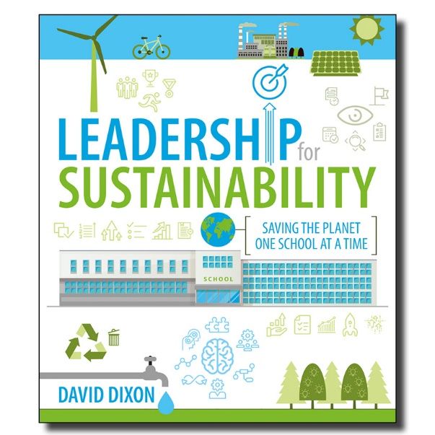
Leadership for Sustainability:
Saving the planet one school
at a time
by David Dixon
ISBN 9781781354018
Published 31st March 2022
www.crownhouse.co.uk

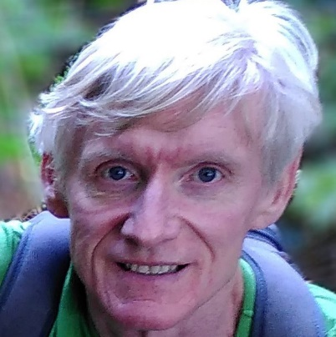
Dr David Dixon was a full-time primary teacher for 15 years before becoming a head teacher for the following two decades. In that time, he promoted the twin causes of environmental education and sustainability, which formed the central ethos of his schools. David is now a freelance education consultant, specialising in curriculum and leadership and helping individual schools to link sustainability with school improvement more generally.

