Taboos in Teaching English – The Question of Why and How?

Julia Ochocińska, Poland
Julia Ochocińska is a freelance ELT editor, materials writer and a language instructor specializing in teaching English for general and business purposes. Julia places a strong focus on enabling smooth and effective communication in personal and professional contexts, which is reflected in her original teaching resources created to familiarize learners with a real-world use of the English language.
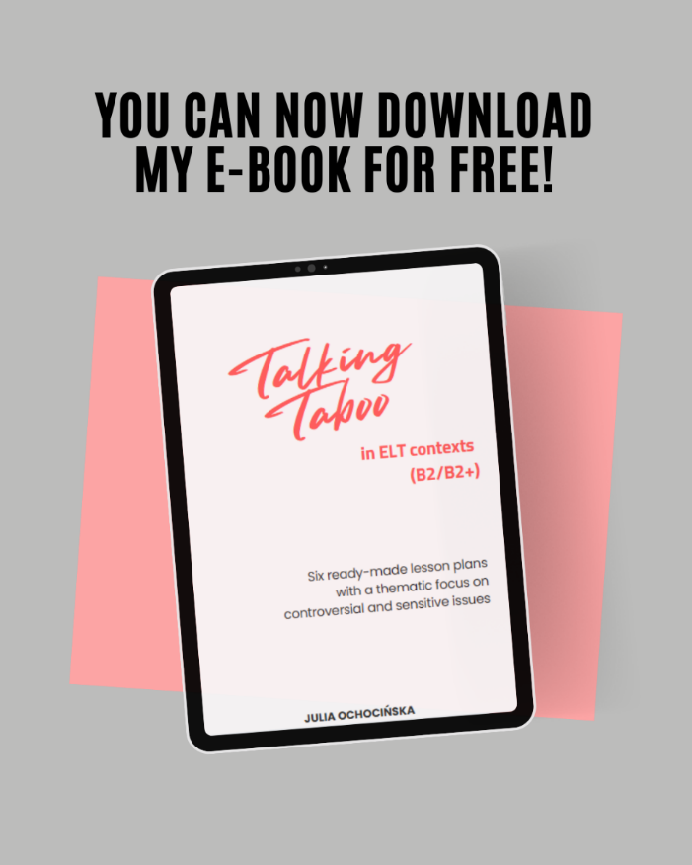
Link to free download

Introduction
I think that as a language instructor who’s been in the field of ELT for almost ten years and has worn many hats in the process – I’m entitled to having some opinions based solely on my observations and experience. I believe that many of you will nod in agreement that we teachers, especially those involved in language education, are quite a unique bunch. What separates us from other educators is a set of unique soft skills and competencies which can be utilized not only as a means to helping our learners on their path to achieving communicative fluency (which unequivocally stands as a primary purpose of language education), but also as a great opportunity to guide them in the process of developing critical and analytical skills, crucial in terms of conscious citizenships.
Confronting the uncomfortable
We can go about it in two different ways – we can either play it safe, stick to the predetermined syllabus and use obsolete teaching materials which are based on safe yet sometimes irrelevant topics or we can go against the grain and step outside our teaching box we’ve unconsciously put ourselves into to navigate difficult conversations, which – let’s be real, are going to happen either way, in more or less (but most likely the latter) constructive environments. Why do so, you may ask? Because let’s face it the current global landscape challenges us to change the way we approach the teaching-learning process, and I believe it’s our responsibility to help our learners become more comfortable with the so-called uncomfortable. I know it’s risky business because there are several aspects that need to be accounted for while having such discussions in the classroom to avoid the broadly defined socio-cultural insensitivity where certain remarks or assumptions – however well-intentioned – can come across as offensive or even alienating. But trust me, when handled with intentionality and a strong commitment to respectful dialogue, it’s worth taking a shot in the end. So don’t be afraid to test the waters, you know your learners best – you know what makes their hearts sing, you know what might cause a sense of unease. You have a clear sense of their language levels and their capacity to engage with complex or sensitive topics. Your expertise allows you to recognise where initial scaffolding might be needed to make sure all learners are linguistically agile enough to participate meaningfully and on equal footing. Don’t get discouraged, help them embrace their discomfort, but don’t push them too hard. Create a safe and supportive space for sharing ideas and experiences, build mutual respect, prioritize open communication and value diverse perspectives. And most importantly, approach the entire process in a more holistic and interdisciplinary manner – language learning should not be an isolated experience, after all.

About the benefits of having difficult conversations in the classroom
If you know anything about me and my teaching practice, I’m certainly not one to shy away from addressing difficult topics in my classroom. In fact, I believe that addressing the so-called ‘taboo’ can foster the development of critical literacy and encourage a culture of mutual respect of other people’s opinions, especially when they differ from our own. I’m a firm believer in the idea that language is a powerful medium of communication and self-expression, a tool which enables us to respond to the new faces of ever-changing reality (no matter how difficult or gloomy it may seem or actually be) and make sense of the overwhelming amount of information we are constantly bombarded with. In this sense, language is a direct reflection of our thoughts and emotions; a reflection of an environment that has shaped us in one way or another. To my mind, there’s no effective communication without the ability to draw conclusions from the world surrounding us. Just think about it for a second, how else can we foster the development of critical thinking skills and what’s even more important – the art of civil discourse if we, whether deliberately or not, avoid certain topics just because they seem difficult, controversial or unacceptable from a social point of view. Let’s take this moment to pause and reflect a bit, shall we? When was the last time you were challenged to deal with sensitive issues in the classroom? Was it something you planned, or did it pop up completely unexpectedly? What topics were mentioned? Did you have a chance to use any resources to facilitate the conversation? How did you feel while moderating that type of in-class discussion? What were your learners’ reactions? What could have been done differently?

The search for appropriate resources – introduction to the e-book
And while navigating tough conversations in the classroom is one thing, there’s no denying how big of a role the selection of appropriate (and what I mean here is thought-challenging but in no way offensive) resources plays in this process. That materials-seeking journey combined with my students’ strive and openness for having meaningful talks were the main motivations behind creating “Talking Taboo in ELT contexts” – an e-book designed specifically to address a wide range of the so-called contemporary controversies – or in other words – topics which are rather pressing from a contemporary perspective, such as immigration, disability, sexuality, gender roles, female empowerment and reproductive freedom. In terms of structure, this resource is a compilation of six ready-made lesson plans aimed to develop critical literacy and encourage a culture of mutual respect of varying opinions in the classroom by engaging your learners with a plethora of stimulating tasks and activities based on authentic resources (e.g. articles, videos, photos) and thought-provoking topics which may serve as a starting point for meaningful in-class debates and discussions. In addition to various speaking components, each chapter includes a vocabulary expanding task corresponding thematically with the central idea of a given unit. As far as the target audience is concerned, because of its subject matter, this e-book is the most suitable for young adults/adults who demonstrate higher levels of proficiency (upper-intermediate to advanced). It’s intended primarily for small group instruction, both in online or offline settings.
Because of its importance in terms of cultivating awareness with regard to topics touching upon diversity, equity and inclusivity, I’ve decided to make it completely free – you can use the link provided below to download the file. And what else can I say, I do hope that this e-book will be your guide to facilitating productive conversations around difficult but highly important social issues, in safe and supportive learning spaces.

Coming soon! Please check the Pilgrims in Segovia Teacher Training courses 2026 at Pilgrims website.

