10 ideas from ETpedia Business English from Pavilion

About the book

ETpedia Business English is every Business English teacher’s complete encyclopaedia. Whether you are training to become a Business English teacher or a more experienced BE teacher, this complete and comprehensive guide will save you time and make life easier. It collates teaching resources, ideas and tips into one simple-to-use reference book. Designed for different teachers at different stages of their career, it supports preparation, planning and professional development.
The simple layout of 50 units makes it easy to find what you are looking for. This then allows you to use the resource according to your need, interest or level of experience.
ETpedia Business English is the second title in the ETpedia series. It was also the winner of the 2016 David Riley Award for Innovation in Business and ESP, an award that recognises creativity and excellence in ELT. The adjudicator of the award said:
‘The decision to award ETpedia Business English the prize was a unanimous one. By bringing together a collection of ideas, tips, tools and techniques for the business English teacher, it looks set to become the one-stop handbook, invaluable not only for new teachers but also for experienced teachers who can dip into it whenever they are looking for fresh inspiration. Congratulations to everyone involved.’
source

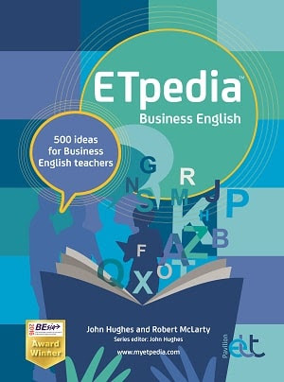
500 ideas for Business English teachers
ETpedia Business English
is every business English teacher’s complete encyclopaedia,
with 500 tips and ideas
to help you get the most out of your students.

TRY OUT 10 SAMPLE IDEAS COLLECTED FROM ACROSS THE BOOK
Download the sample here

About the series


Last year marked the 10 year anniversary of the launch of the ETpedia series! The series offers English language teachers across the world thousands of practical teaching tips, ideas and activities. Each book in the series is divided into units of 10 tips on a particular theme or topic, perfect for dipping into whenever needed.

Coming soon! Please check the Pilgrims in Segovia Teacher Training courses 2026 at Pilgrims website.

